University College London
Division of Surgery and Interventional Science
3rd Year Research Project Report, 2024-2025

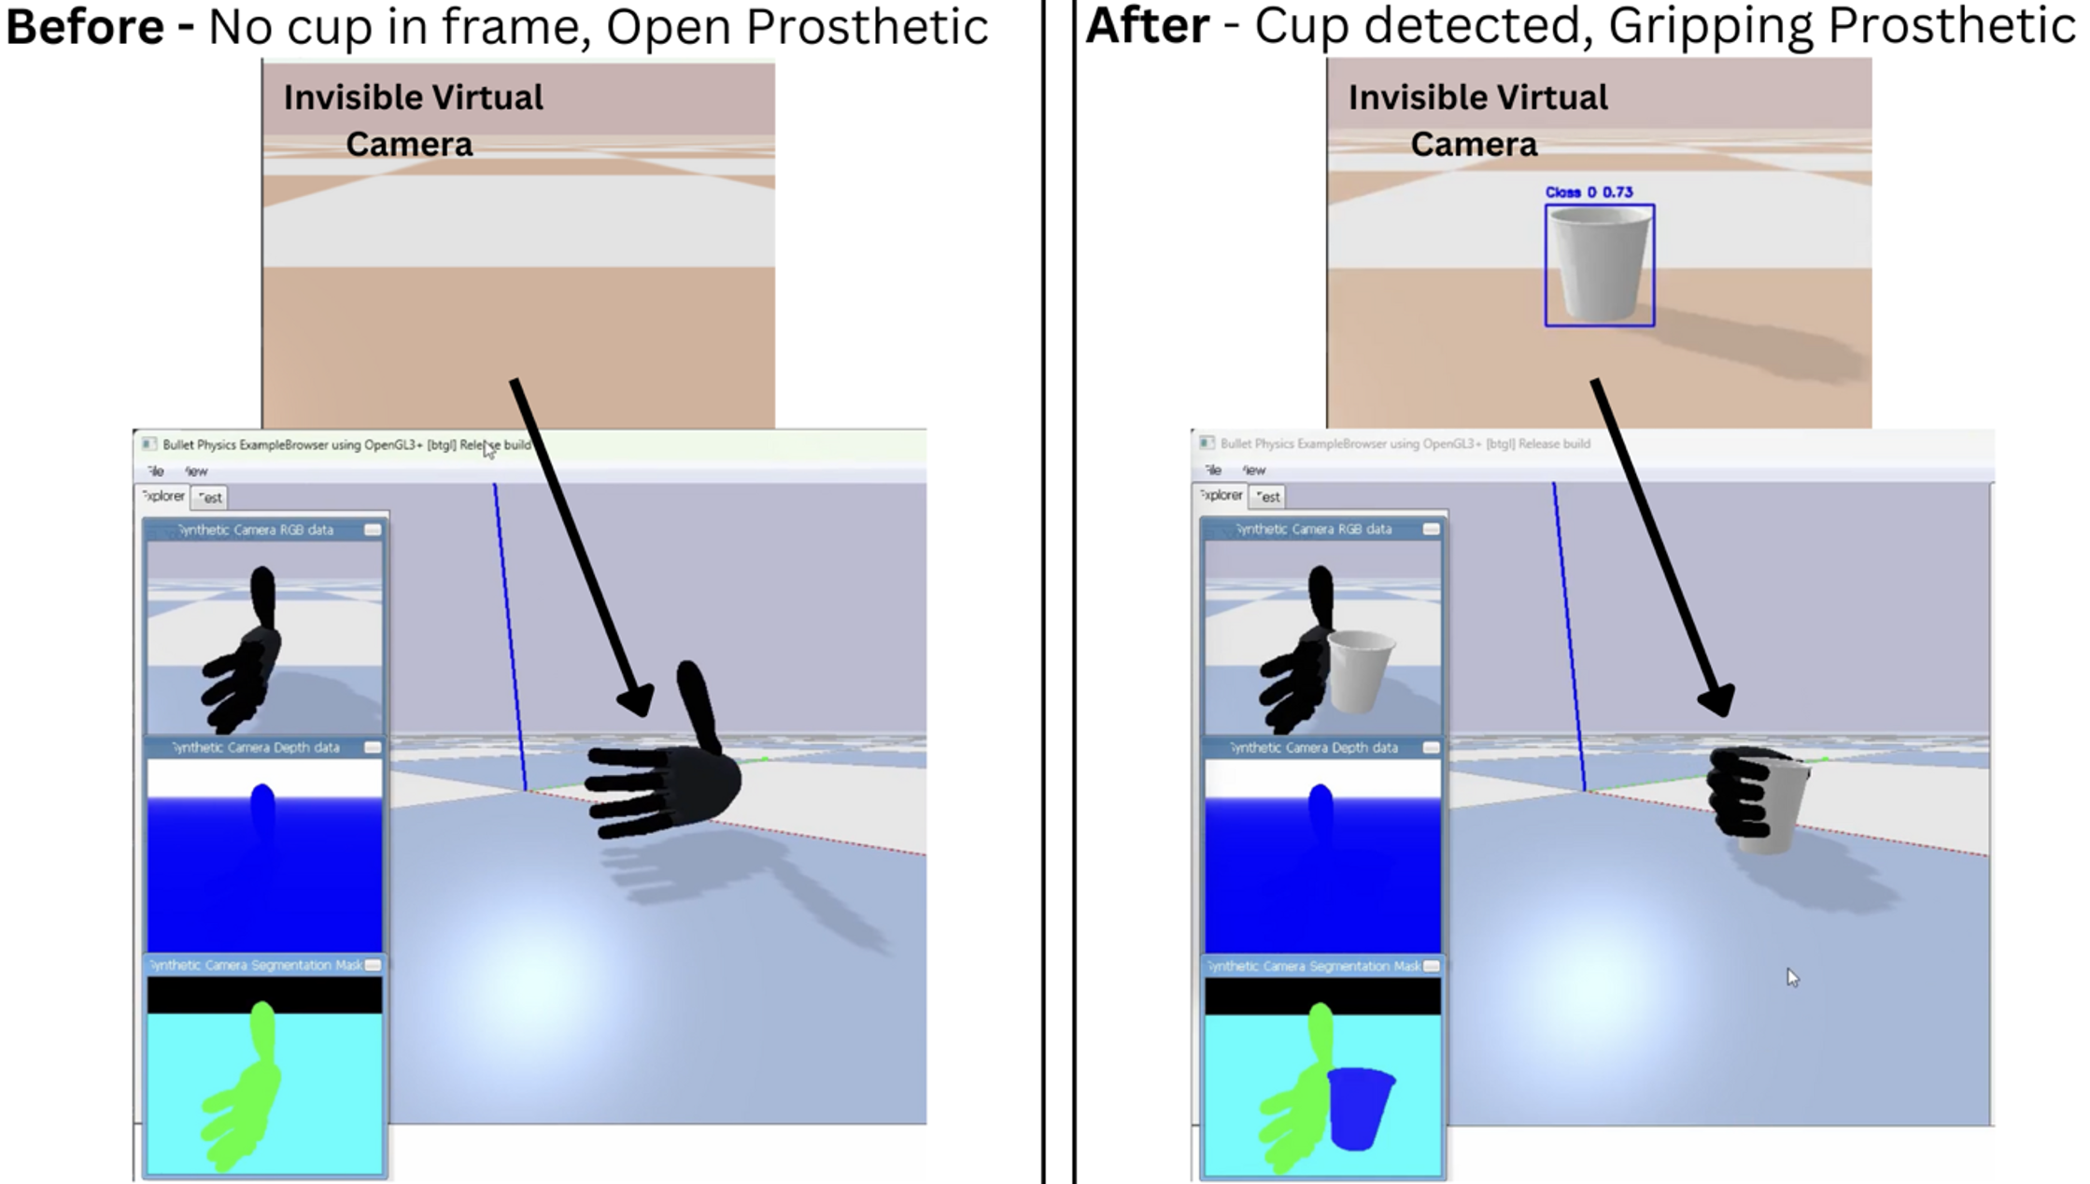

Project title: Enhancing Bionic Prosthetic Hands Using Computer Vision and Reinforcement Learning in a Simulated Physics Environment
Student number: 22108112
Module: SURG0161
Word count: 5500
ABSTRACT
Myoelectric prostheses lack autonomous, dynamic responses to objects, limiting their usability. This project presents a novel integration of computer vision (CV) and reinforcement learning (RL) using a YOLOv11 object detection model and RL force-feedback-driven grip controller to automatically grasp objects and improve grip stability on a simulated bionic prosthetic hand. The intention is to make the hand behave closer to a real one. Using PyBullet with OpenAI Gym and Stable-Baselines3, the system was trained entirely in simulation with minimal sensors. The YOLOv11-nano detector achieved 83.1% object detection accuracy (precision 78.0 %; recall 80.7 %; F1 score 79.3%), and a real-time capable 0.09 s inference (mean 0.0853 ± 0.0041 s; 95 % CI [0.0846 – 0.0860]), well below the 0.25 s average human visual reaction time, with an average confidence of 87.7% (mean 87.7 ± 6.46 %; 95 % CI [86.5 – 88.9]). The RL agent lowered excessive force application by 32% relative to the standard bionic hand but occasionally applied excessive force (up to 273%), indicating demand for reward-function refinement. A 27% average slip reduction and 87.2% better force distribution were seen, meaning more reliable object holding. These results demonstrate that combining CV and RL can improve prosthetic grasp stability. Future work will integrate visual information into the RL policy and fuse the autonomous controller with myoelectric signals in a shared-control framework, boosting user autonomy and quality of life for more intuitive, reliable grasping.

Table of Contents
1 INTRODUCTION 4
1.1 Medical need for prosthetic hands with adaptive and optimised grip 4
1.1.1 Medical Need 4
1.1.2 Limitations of current prosthetic hands 4
1.1.3 Shared control between human and an intelligent bionic prosthetic hand 7
1.2 Role of Computer Vision, Reinforcement Learning, and Simulated environment in Enhancing Bionic Prosthetics 7
1.2.1 Machine Learning for Intelligent Prosthetic Hands 7
1.2.2 Computer Vision for Object Recognition and Adaptive Grasping 7
1.2.3 Reinforcement Learning for Grip Optimisation 10
1.3 Aims of the Project 11
1.4 Hypotheses 12
2 MATERIALS AND METHODS 13
2.1 Pre-considerations: Grip type, Objects and Prosthetic 13
2.2 Simulation Environment Design 14
2.3 Object Detection Framework and System 16
2.4 Reinforcement Learning Framework 19
2.5 Evaluation Metrics and Statistical Analysis 21
3 RESULTS 22
3.1 Computer Vision augmentation 22
3.2 Reinforcement Learning Model Performance and comparison with Non-AI enhanced prosthetic 26
3.2.1 Single-Experiment Model Performance 26
3.2.2 All-Experiments Model Performance 27
4 DISCUSSION 31
4.1 Computer Vision Algorithm 31
4.1.1 Key Outcomes and Limitations 31
4.1.2 Context Within the State-of-the- Art and Future Work 31
4.2 Reinforcement Learning Algorithm 32
4.2.1 Key Outcomes and Limitations 32
4.2.2 Context Within the State-of-the- Art and Future work 32
5 CONCLUSIONS AND A VISION OF THE FUTURE 33
6 SUSTAINABILITY STATEMENT 34
7 EQUALITY, DIVERSITY AND INCLUSION STATEMENT 34
8 ACKNOWLEDGEMENTS 34
9 REFERENCES 35
10 LIST OF ABBREVIATIONS 40
11. APPENDIX 40

1 INTRODUCTION

1.1 Medical need for prosthetic hands with adaptive and optimised grip

1.1.1 Medical Need
Despite decades of innovation, prosthetic hands achieve only a fraction of a natural hand’s dexterity. A 2016 study on upper-limb prosthetics users showed general movement, ease of use and grip functionality to be key concerns (1). Users must manually adjust grip-types and force, resulting in high cognitive burden and poor satisfaction in users. In its 2022 Clinical Commissioning Policy, the NHS formally recognised these limitations, emphasising the need for multi-grip prosthetics with advanced control mechanisms (2). However, most current devices still fail to provide fully adaptive and quality grip control, limiting the real-world usability of these prosthetics and their frequent abandonment (3).

1.1.2 Limitations of current prosthetic hands
The concept of a prosthetic hand dates back to the roman period, where according to Pliny the Elder, a general's hand was replaced with one ‘of iron’, allowing him to return to battle (4). Body-powered prosthetics have since been the standard for centuries, due to their basic-functional design and durability (5). The Hosmer Hook, shown in Figure 1, is a recent model typically provided by the NHS to amputees. It uses a harness and cable system to translate residual shoulder movement into mechanical actions (6). Its simple design is cheap and low maintenance; however, it has many limitations, outlined in Table 1.

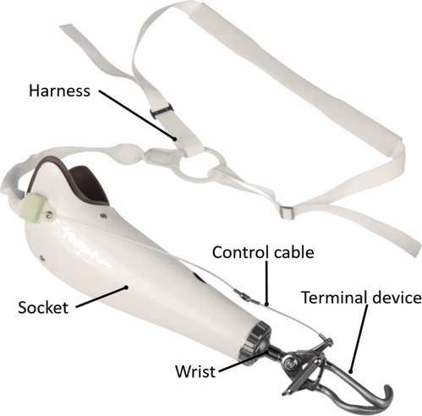
Figure 1: Shows the Hosmer Hook. While it is functional, it has a limited range of use, only able to pick up a narrow range of basic items (7)

Limitation | Description
High Activation Force Requirement | Many models require significant force to operate, up to 117 ± 6.4 N (8). Considering no shoulder force is needed to generate a grasp with a real hand, this means more physical effort from the amputee compared to someone with an intact arm.
Limited Functionality | Body powered prosthetic primarily support gross grasping movements, making it unsuitable for fine motor tasks. It is considered an assistive device rather than a functional replacement hand (9).
Visual Feedback Issues | Some versions can obstruct the user's line of sight. Swartz et al reported that a patient rejected a prosthetic due to this issue (10).
Fatigue Concerns | Over 50% of subjects in a study by Hichert et al struggled to use the prostheses they studied, including the Hosmer hook, without fatigue. For example, the Hook 5XA requires 71N of cable force, and only 6 out of 23 subjects could operate it without fatigue daily (11).
Table 1: Shows the key limitations of body powered prosthetics.
There has been a push for more useful and intuitive prosthetics, the first clinically significant robotic one released by Alexander Kobrinski in 1960 (12). Robotic, or bionic, hands are now the cutting-edge in prosthetic technology. Known as myoelectric prosthetics, they detect electrical impulses from muscles in residual parts of limbs to control the hand, the Ability Hand by Psyonic, shown in figure 3, is an example. Aiming to provide more natural and dynamic movements, it offers several advantages over body-powered alternatives, being lighter and more comfortable to use. More recent models feature multi-grip functionality, enabling handling of objects of varying shapes and sizes (13). However, this is not automatic, and it only offers 6-degrees of freedom compared to the human hands 27. Myoelectric prosthetics in general face significant challenges, presented in Table 2. These limitations contribute to high rejection rates, some studies reporting abandonment rates of up to 75% (14,15).
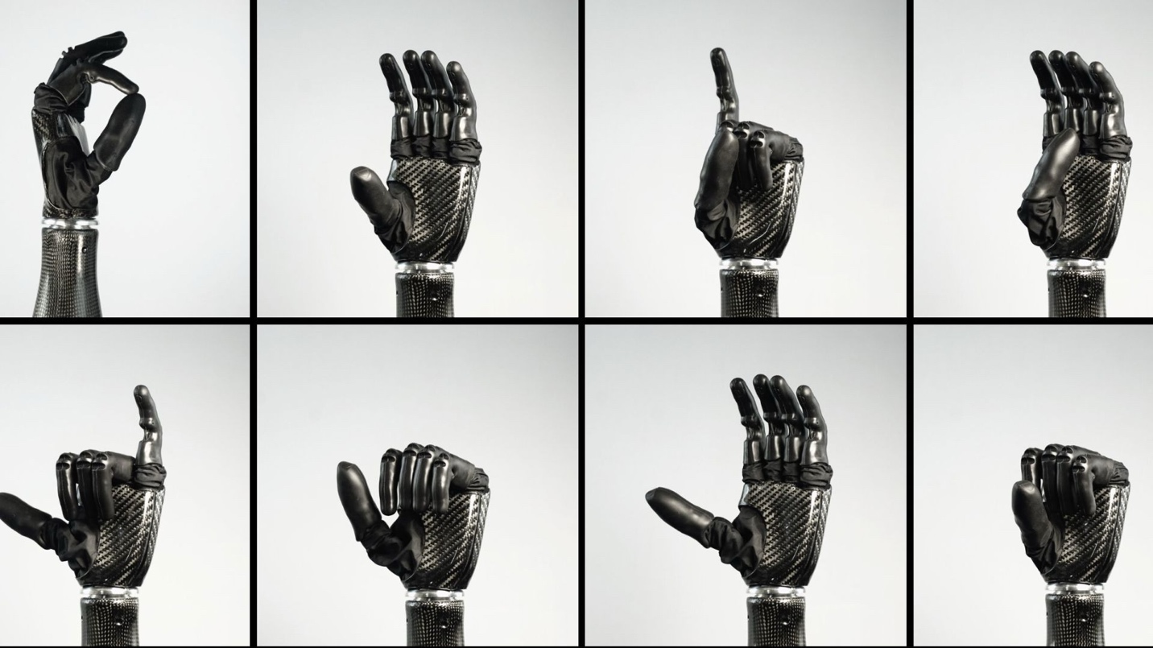
Figure 2: The Ability Hand in 8 different configurations (from top to bottom, left to right: precision pinch, cylindrical power grip (readying), pointing gesture, open-hand thumb down-position, shaka hand sign, cylindrical power grip (closed), open-hand, fist)(16).

Limitation | Description
Unnatural Control | Chen et al found that users often found myoelectric prostheses unintuitive and difficult to control, leading to passive use or complete abandonment of the system. The methods of control of different grip types and wrist functions in myoelectric prostheses felt unnatural, contributing to these high rejection rates (17).
Unpredictability in EMG Signals | Electrode misalignment in the sheath of the prosthetic adds noise and undermines control reliability: Wang et al. achieved just 65.40 ± 8.23 % accuracy in recognising electrode shifts, underscoring myoelectric systems’ sensitivity to placement (18).
Limited real-world functionality | Bouwsema et al show that, even with training, prosthesis users plateau at 56 on the Southampton Hand Assessment Procedure (SHAP), a standardized test that measures how well a hand performs everyday object-handling tasks, producing an overall functionality score. This is far below the 95–100 scored by a real hand, and they still struggle to master grip-force control because the prosthesis provides limited proprioceptive or tactile feedback, highlighting the minimal real-world utility of bionic hands (19).
High Cognitive Load | Operating myoelectric prostheses requires significant cognitive effort, largely due to their reliance on visual feedback, making control mentally demanding for users (20).
Grip instability | The Ottobock Bionic Hand relies on fixed control, making its capacity for adaptive grasping and overall stability constrained, a limitation underscored by Tawfik et al’s slip-detection study, which highlights persistent concerns about grip instability in prosthetic hands (21). Although not a prosthetic, Khin et al similarly report that during object lifting, their soft-robotic hand prototype exhibited tilting and slight shifts due to acceleration and insufficient grasp strength, manifesting as slippage events that their stability estimation network detected with 85.16–89.96 % accuracy (22). This still demonstrates that robotic hands in general have this problem.
Use training | Riet et al. share that at least four months of daily training is required to use a prosthetic hand. By this point, users may have already become frustrated and stopped using it all together (23).
Table 2: The limitations of myoelectric prosthetic hands.
Since myoelectric prosthetic hands appeared over 60 years ago, there has been limited evolution of the technology. The cognitive load on users and learning curve is high, control is not natural, and grip-stability is an issue. However, the rise of AI‐driven shared‐control systems offers a promising solution to these challenges.

1.1.3 Shared control between human and an intelligent bionic prosthetic hand
Shared control, where the decision-making process is distributed between the user and an intelligent device, has emerged as a strategy to reduce the cognitive burden on users in assistive technologies (24). Carlson et al. applied it to brain-controlled wheelchairs, giving the chair its own “brain” to handle cumbersome tasks without direct effort from the user (25). Artificial intelligence (AI) algorithms form the foundation of this technology (26), yet AI-driven shared control remains almost unexplored in prosthetic hands. A PubMed search (27) returned only one marginally relevant study by Khadivar et al (28). They used AI to decode Electromyograph (EMG) signals to change the angles of the fingers of a bionic hand. Its effectiveness is limited by the inherent noise in EMG signals, and accurately decoding user intentions across varying arm and wrist orientations without extensive calibration means it is still a cumbersome approach. More innovative techniques are needed to enhance bionic hand control.

1.2 Role of Computer Vision, Reinforcement Learning, and Simulated environment in Enhancing Bionic Prosthetics

1.2.1 Machine Learning for Intelligent Prosthetic Hands
AI is making a huge impact on medicine, the market projected to grow from $17.2 billion in 2025 to $77.5 billion by 2035 (29). AI is built on Machine Learning (ML) algorithms that learn from data, recognise patterns and make decisions without explicit programming (30). This project adopts two specific ML techniques; computer vision (CV) and reinforcement learning (RL).

1.2.2 Computer Vision for Object Recognition and Adaptive Grasping
CV enables machines to interpret what they see (31). Supervised learning is the most common method. It involves training algorithms on pre-labelled datasets that have sections of the image, like an object, identified with a box around it. This object is assigned a class label (e.g. cup), so the algorithm can classify similar objects in new data. By capturing an object’s pixel patterns, algorithms can recognise similar ones in unseen examples. Object detection is a common CV task. First, an encoder known as a convolutional neural network (CNN) processes the input image to extract visual features. A unified detection head then operates on those features, simultaneously predicting bounding box coordinates and estimating a confidence score to the object it has detected, predicting the probability that what its detected is one of the class labels (32). Finally, the output is the localised object with a confidence score applied to it. The basic protocol is exemplified with a banana on Figure 3.
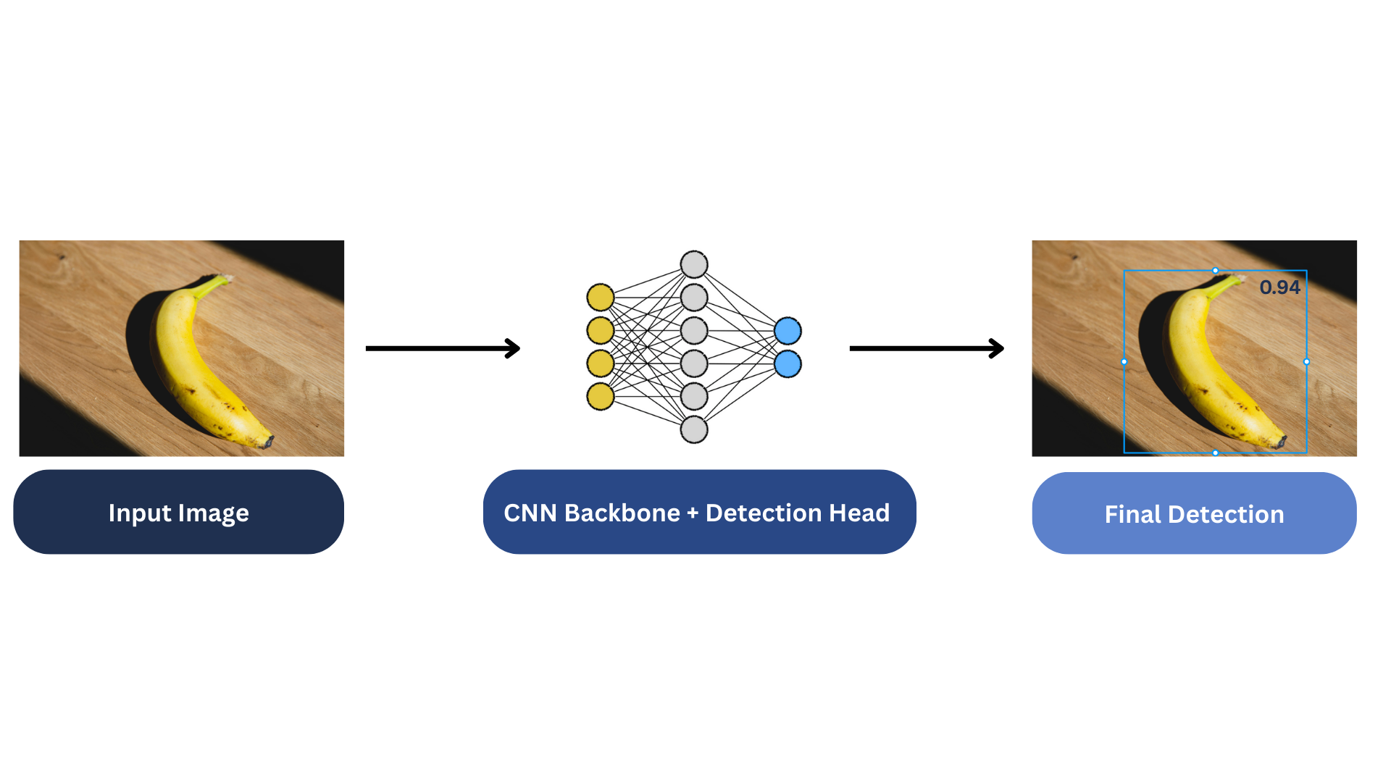
Figure 3: End-to-end object detection pipeline applied to a banana. On the left the raw input image, in the centre the shared CNN backbone and unified detection head, and on the right the final output showing a bounding box and its confidence score.

Just as Hawkins et al.’s real-time tissue and tool classification system, shown in Figure 4, guides surgeons during endoscopic spinal surgeries (33), integrating CV onto myoelectric hands allows automatic object detection.
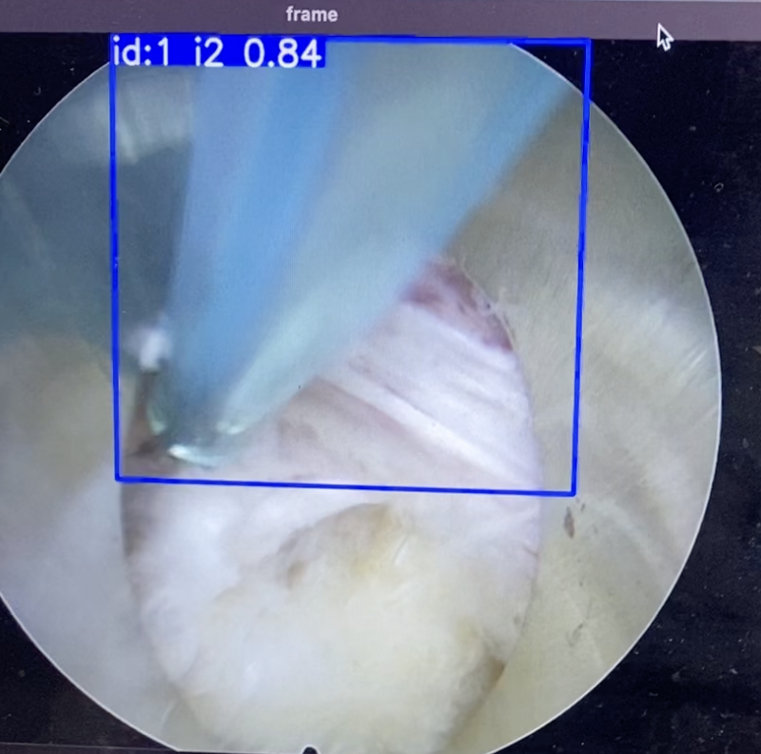
Figure 4: Endoscopic spinal surgery view with real-time object detection overlay: the radiofrequency probe is enclosed in a bounding box, labelled “i2,” and detected with 84 % confidence (34).

CV already lets myoelectric hands ‘see’ objects, yet current prototypes are still far from natural in performance. Nazarpour et al at Newcastle University attached a camera to a commercial myoelectric hand, shown on Figure 5, and used a CNN to sort objects into four grasp categories: palm-neutral, palm-pronated, tripod and pinch (35). The hand selected and executed the grasp within a few hundred milliseconds, an order of magnitude faster than EMG control, enabling automatic grasping. However, there is still work to be done as the prototype lacks adaptive force control and worsens in performance with unseen objects, unlike humans who adapt rapidly. To address these limitations, RL-driven control could be incorporated.
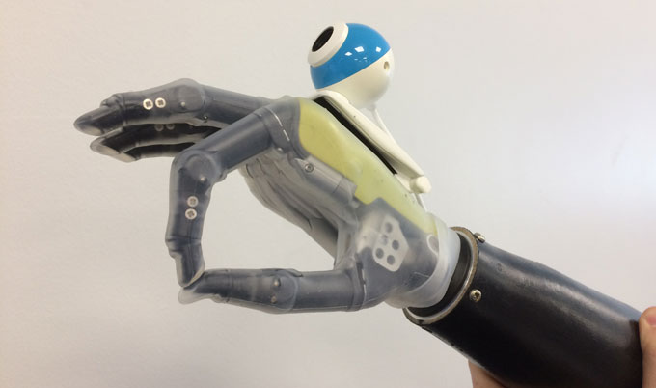
Figure 5: The Newcastle ‘Hand-That-Sees’ in the pinch grip orientation, with a camera attached to the dorsum of the hand (35).

1.2.3 Reinforcement Learning for Grip Optimisation
RL works differently to CV. An agent uses a parametrised policy, mapping from states to actions often using a neural network, to learn via trial and error by interacting with an environment. After each action, the environment returns a new state and a scalar reward, computed by a reward function, that the agent seeks to maximise over time. The learning process balances exploration, meaning trying novel actions, against leveraging known good actions, known as exploitation, to accumulate the highest cumulative reward (36). A simple schematic of this loop is shown in Figure 6.

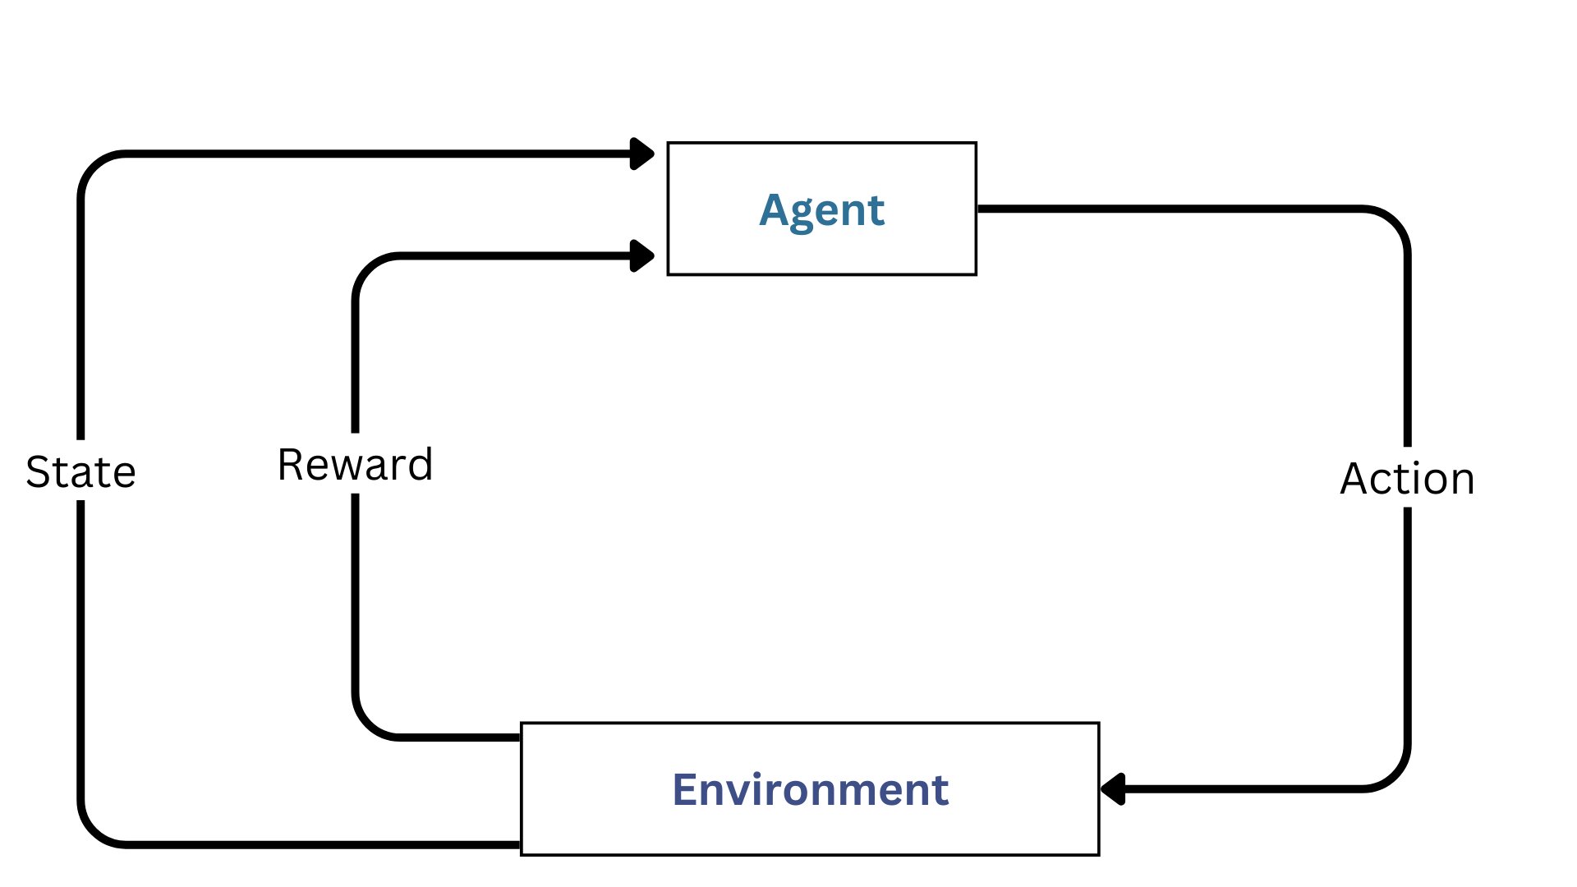
Figure 6: The RL agent, optimises the desired outcome through adjusting its actions, which reflects a change in environment. Based on the outcome, a reward is calculated and given to the agent. The final state of the environment is also recorded for logging purposes.
RL has been applied to anthropomorphic robotic arms to improve their manipulation and control of objects (37), however this approach to advance bionic prosthetic hands appears almost untouched. A search on PubMed combining “prosthetic hand” and “reinforcement learning” returned only 11 results (38). The most relevant was a 2024 study by Odeyemi et al that used machine learning to learn how to pick up objects (39). Their work simulated a simple two-finger gripper, the WSG50 parallel gripper, which does not reflect the complexity of modern-day myoelectric prosthetics. No prior study appears to have implemented RL on a fully anthropomorphic prosthetic hand with multi-digit control, nor to optimise such grip. This represents a significant research gap and an opportunity to advance the field.

1.3 Aims of the Project
Currently, both body-powered and myoelectric prosthetic hands leave users with limited, non-adaptive hand function. AI techniques offer a route to smarter, more life-like prosthesis control. Yet, the intersection of AI and prosthetic hand control remains largely unexplored. It appears there is no existing prosthetic hand system that uses both real-time computer vision to recognise objects and reinforcement learning to autonomously optimise grip forces. This project starts to fill that gap by developing an AI-enhanced prototype hand that marries CV and RL on an existing prosthetic hand, in a simulated environment, meeting the NHS’s call for low-burden multi-grip devices (2), and avoiding the need for new, expensive hardware.
The project focuses on detecting the presence and grasping of cups. The CV model identifies the presence of a cup and selects the grip, and the RL model fine tunes this grip. The CV model was developed and ran under 4 test conditions, baseline, poor lighting, occlusion and clutter, to evaluate its ability to detect an object in real-world settings. The RL controller was tested in six grasp scenarios, plastic, glass, and ceramic cups, each empty and full, to check whether the hand maintains a stable grip across changes in mass, friction, and size.
The simulated hand is equipped with an on-board camera to identify the target cup and automatically select the appropriate grip. A reinforcement learning controller fine-tunes the forces applied by each finger, striving to maximise grip stability, preventing slips or drops, while minimising excessive force. Figure 7 visually explains this approach. The end goal is to have the CV act as a high-level “where and what” module, the RL grasp optimiser to act as the low-level “how hard to grip” module and the user to be the guide to these using myoelectric control.
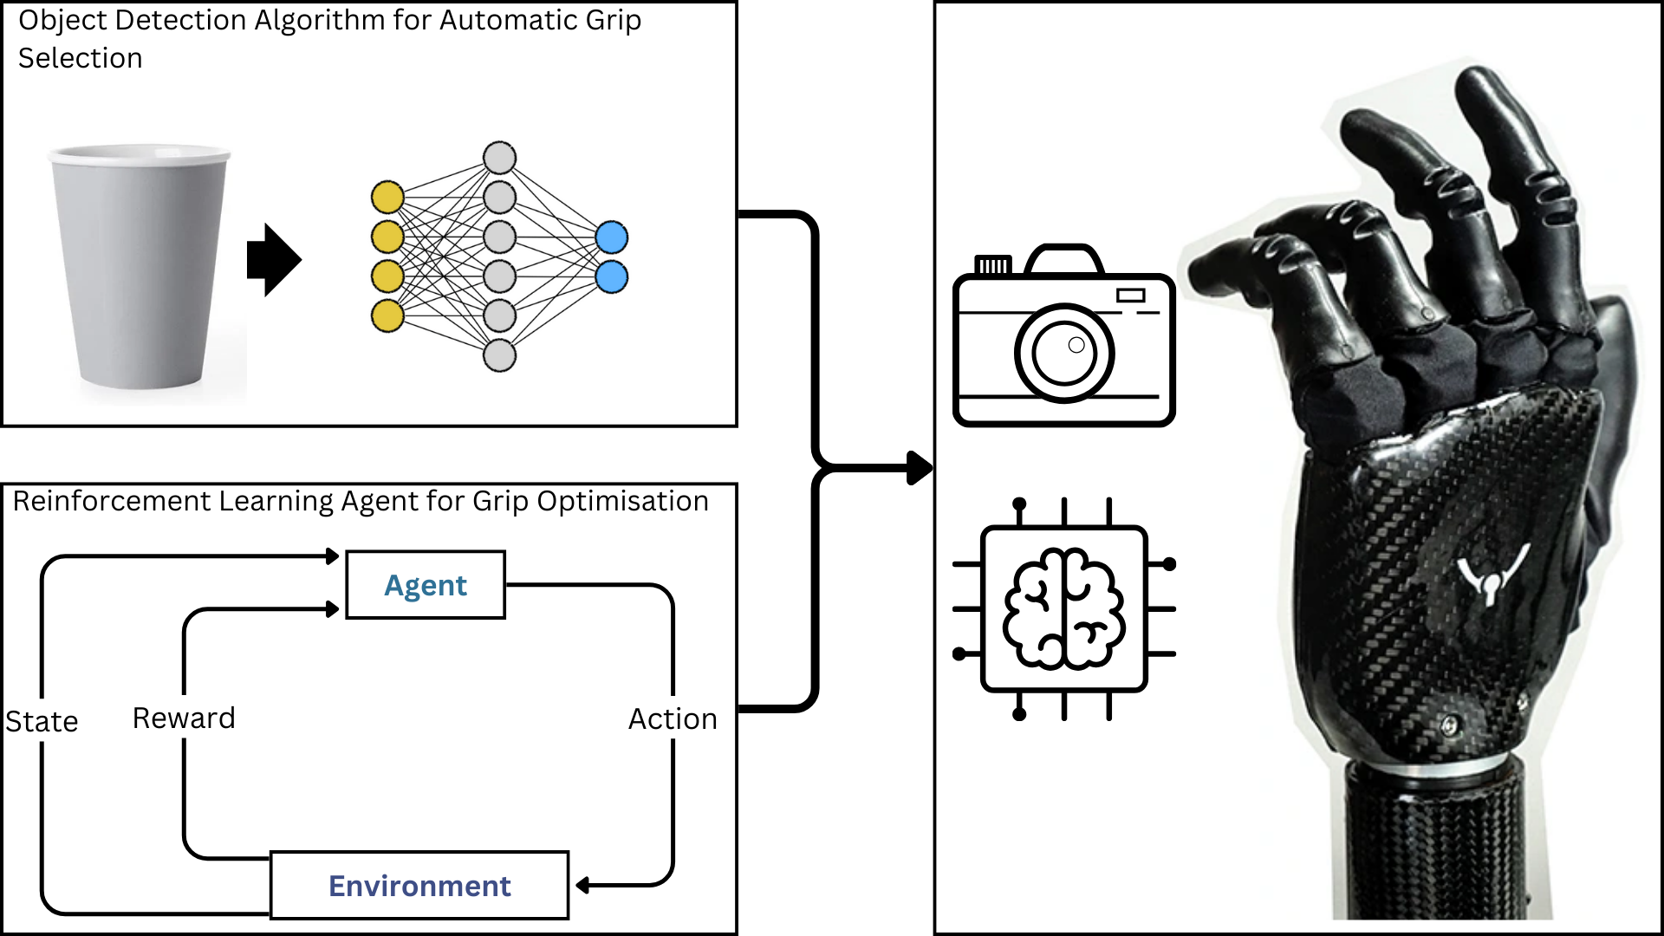
Figure 7: Shows how a CNN-based object detector first identifies the target and suggests a grip, then a reinforcement learning agent refines grip forces by executing finger force adjustments, and rewarding stable, slip-free grasps. The resulting optimised commands are deployed on the prosthetic hand (16) in real time for dynamic and adaptive gripping. It’s important to emphasize that these are supposed to work in conjunction with each other and with a user-controlled prosthetic, as a shared control mechanism.

1.4 Hypotheses
To evaluate the proposed AI-enhanced prosthetic system, five hypotheses where formed, addressing both the computer vision model and the reinforcement learning controller’s effectiveness, shown on 3X. Each hypothesis is stated with a null hypothesis (H₀) and an alternative hypothesis (H₁) for statistical testing:
 | Performance metric (component) | Null hypothesis (H₀) | Alternative hypothesis (H₁)
1 | Cup-detection confidence (CV) | There is no significant difference in cup detection confidence across the four conditions (Baseline, Poor Lighting, Occlusion, Clutter). | At least one condition yields significantly different cup detection confidence.
2 | Inference time (CV) | Inference time does not differ significantly across the four conditions. | At least one condition produces a significantly different inference time.
3 | Mean grip force (RL) | The average grip force required is the same for the RL enhanced hand and the non RL hand across trials. | The RL enhanced hand applies a significantly different grip force across trials.
4 | Overall slip / displacement (RL) | There is no significant difference in average slip between the RL enhanced hand and the non RL hand across trials. | The RL enhanced hand exhibits significantly different slip across trials.
5 | Force-distribution variability across actuators (RL) | Force distribution variability across actuators is the same for RL and non-RL hands across trials. | Force distribution variability differs significantly between the two, with the RL model showing a more uniform distribution across trials.
Figure 3: Hypotheses 1 and 2 validate the CV component, testing if the object detector can maintain high confidence and real-time speed even under suboptimal viewing conditions, so it provides accurate and quick grip-selection. Hypotheses 3, 4, and 5 evaluate the RL-based control, examining whether the intelligent prosthetic hand can achieve a secure grip with less force, prevent object slips, and mimic a human-like even force distribution, compared to a conventional non-learning controller. Confirmation of the alternative hypotheses, with high confidence and fast gripping time, lower force grip and slip, and more even force distribution, would support the conclusion that the AI-enhanced prosthetic hand provides automatic and naturalistic grasping, and is suitable to assist users.

2 MATERIALS AND METHODS

2.1 Pre-considerations: Grip type, Objects and Prosthetic
The project focused on grasping three types of drinking containers, included plastic, glass, and ceramic cups in both empty and full conditions, resulting in six experiment types. A single grip type, the cylindrical power grip, was used, being the most effective way to grasp cups (40). The Ability Hand was used as a model for the simulated prosthetic hand because its six degrees of freedom and predefined grasp patterns (13) make it simpler to simulate, and its current use in cutting-edge research institutions, such as ETH Zurich and the Shirley Ryan Ability Lab, make it an industry standard and reliable for the project (41). The object properties, including mass, dimensions, and coefficients of friction between objects and the silicon-rubber surface of the hand, were estimated based on literature and in‐house measurements, detailed on Table 4.
Cup Type | Material | Empty Mass (g) | Full Mass (with water) (g) | Height (m) | Diameter (m) | Coefficient of Friction between object and hand
Standard Plastic Cup | Plastic (HDPE) | 6 | 258 | 0.110 | 0.060 | 0.6 (42)
Pint Glass | Glass | 265 | 809 | 0.160 | 0.065 | 0.9 (43)
Standard Ceramic Cup | Ceramic (glazed, handleless) | 364 | 600 | 0.091 | 0.083 | 0.9 - Assumed to be the same as glass as it has a glazed glass surface (44)
Table 4: Physical properties and coefficients of friction for the cups used in the experiment. Friction sources are cited alongside each value.

2.2 Simulation Environment Design
Experiments ran on a Windows 11 PC with an AMD Ryzen 7 2700X, 16 GB RAM, and an NVIDIA RTX 3070. Python 3.13 was chosen to code the project due to its rich scientific and ML libraries, and cross-platform compatibility, simplifying reproducibility on other devices. The open-source simulator, PyBullet 3.2.5, was used for its real-time, graphics-processing-unit accelerated rigid body dynamics, and native Unified Robot Description Format (URDF) importing, a file that describes a robot’s links, joints, and physical properties. This enabled efficient, high-fidelity replication of the Ability hand’s interaction with the cups (45). The hand URDF was created and made open source by Psyonic, released on GitHub (46). The Ability Hand was imported via URDF with adjusted actuator force limits based on its real-life specifications, all listed on Table 5 (47). Due to the unavailability of the physical hardware, and incomplete technical specifications from the manufacturer, inertial and friction parameters between parts of the hand were defaulted to the values provided by the URDF. Force feedback sensors are embedded in each link, defined in Figure 8.
Specification | Value
Weight | 495 g
Dimensions  Length × Width × Depth | 200 × 110 × 55 mm
Max Grip Force (Cylindrical Power Grasp) | 66 N - Used to estimate the max force the actuators between the links could generate
Max Grip Speed (Power Grasp) | 375 °/s (finger actuator + thumb flexion actuator)  550 °/s (thumb rotator actuator)
Table 5: Specifications of the Ability Hand URDF based on those reported for the real hand (47).
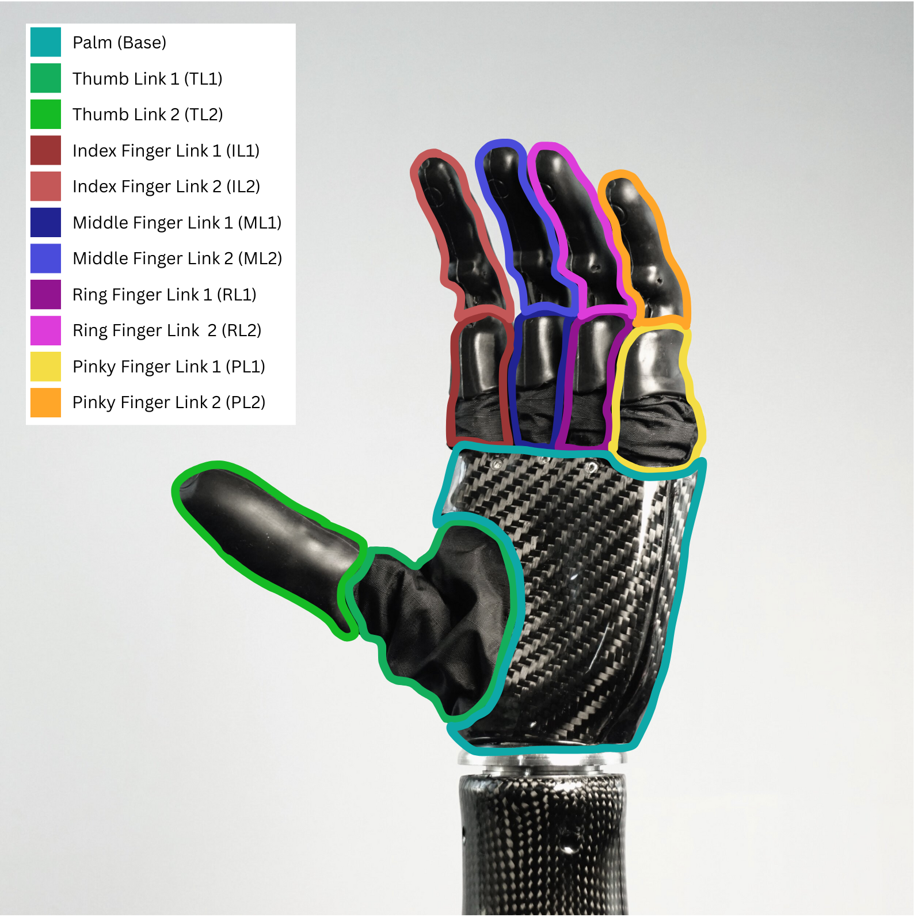
Figure 8: Colour coded link map of the Psyonic Ability Hand (16). Contours overlaying the hand mark each link, where each of the force sensors are. The scheme matches links used in the force distribution plots.
An unenhanced prosthetic, replicating real-world functionality, served as the baseline for comparison with the AI-enhanced version. Gravity was set to a realistic –9.81 m/s² and the physics engine was configured with a fixed time‐step of 1/240 s, default by the PyBullet documentation due to it being stable for contact robotics models. Changing it to larger steps introduced unintentional jitter and missed contact between hand and objects (48). The solver was set to 75 iterations per step after empirical testing. This helped remove joint jitter while still running fast enough to run in real-time. A flat plane was loaded as the ground, then the Ability Hand URDF was loaded at a fixed base position [0.4, 0, 0.05] m with a 90° rotation about its X-axis, so that the hand was lifted in the sagittal plane, reaching for the cup.
Next, two joint‐position dictionaries, “open” and “closed”, were created by querying each joint’s limits and setting them so they be in a closed configuration. Before each trial, the hand was set to its fully open posture using ‘position-control’, standardising the starting pose. From that point onward, the hand was ready to perform grasping trials
To focus on grip mechanics, only the cup model, shown in Figure 9, was used, varying its scale and material properties for each experiment. The hand was locked in a grasp-ready position beside the cup to standardise grasps. A slight tremor in the form of 0.1N perturbations during each grasp was applied to the hand to mimic the instability seen in amputees using prosthetics, as reported by Fletcher et al (49). Random 1-5 N lateral perturbations were added through a “shake test”, inspired by Basumatary et al’s approach to test their own RL robotic hand designed to minimise object slippage (50), assessing grip stability under slippage-inducing conditions. This mimicked real-world disturbances (bumps, vibrations, and minor impacts). This was done over 30 trials to meet the Central Limit Theorem and approximate a normal distribution of the sample mean, though later a Shapiro–Wilk revealed the data remained non-normal (51). This shake test procedure directly links to the evaluation of H₄ and H₅. All performance metrics, such as contact forces and object displacement under disturbance, were logged to an excel file for further analysis.

2.3 Object Detection Framework and System
The object detection model was built using YOLO (You-Only-Look-Once) v11 from Ultralytics, for its ability to process 30 frames per second in real time and achieve high classification accuracy on the detected objects. It’s CNN architecture simultaneously predicts bounding boxes and class probabilities by dividing an image into a grid (52). The model was pre-trained on Microsoft’s COCO dataset, a large-scale benchmark for object detection, provided by Lin et al (53). The object detection algorithm was then fine-tuned by training it in Google Collab on a cup dataset consisting of 653 labelled images that contained cups, glasses and mugs (54), with the hyperparameters detailed on Table 6. The dataset was randomly divided into 78% training and 22% testing data, a common split in image processing that reduces overfitting while ensuring robust evaluation (55). Training metrics are on Figure A1.
Hyperparameter | Value | Description
Model variant | yolo11n.pt | Nano-sized YOLO with pre-trained weights was chosen due to its ultra-lightweight architecture and fast inference speed, meaning when implemented into real prosthetic hardware it can perform real-time object detection with minimal power consumption and low latency.
Epochs | 50 | Number of full passes through the training set
Image size | 640 × 640 | Input image resolution in pixels
Batch size | 32 | Number of images per training batch
Table 6: Key hyperparameters specified for YOLO training: the chosen model weights (yolo11n.pt), total training epochs, input image resolution, and batch size. All other parameters were left at the Ultralytics library defaults for the selected model (56).
In simulation, a 640 × 640 pixel virtual camera, loaded with the best trained model weights, was mounted on the dorsum of the prosthetic hand to detect and track the target cup, mirroring the configuration used on the Newcastle Hand (35). One 3D cup object model (57) was used to test this in real time. One 3D-Cup model was tested due to time constraints, 3D model availability and the cost of high-quality models. Figure 9 shows the object detection protocol, paired with the auto-grasping feature. In this case, the cylindrical power grip was mapped to the cup.
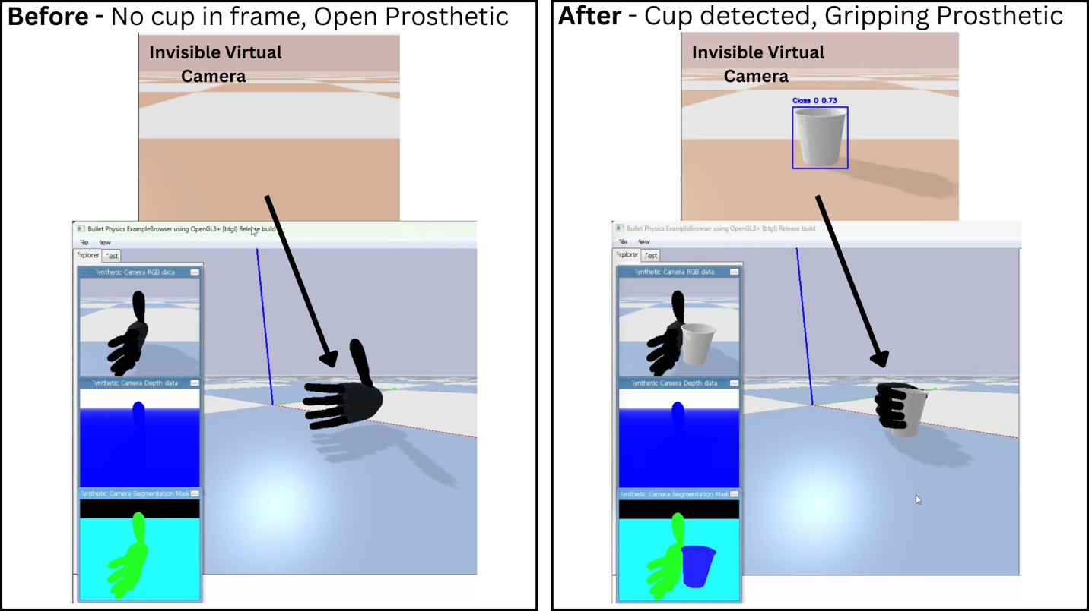
Figure 9: Shows the object detection leading to auto grasp selection. A virtual camera on the hand runs the object detection algorithm, identifying the cup (73% certainty, Class label 0 = Plastic Cup) and triggering a cylindrical power grip. The second synthetic camera, providing a head-on view of the grasp to show it more clearly, appears delayed due to computational lag. The raw video frames are fed to the algorithm, allowing it to identify the object.
To reflect real-life performance, the object detection algorithm was tested under four simulated conditions, outlined in Table 7. Thirty detection cycles were run. The mean average precision score and inference time (time to process the frame) across runs was computed. This evaluation directly tests H₁ and H₂ across the four simulated scenarios. The model’s performance was evaluated exclusively on cups to align with this prototype’s narrowed scope on a single clinically relevant grasp type and to simplify data analysis.
Condition | Change | Real-World Scenario To Reflect
Baseline   | None (optimal lighting, clear view) | Well-lit room or sunny outdoor setting
Low light  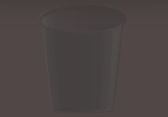 | Illumination reduced to 40 % | Dawn, dusk, or dimly lit indoor spaces
Occlusion  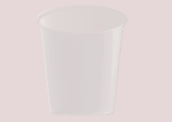 | 50 % white overlay (partial occlusion) | Foggy weather or steamy environments
Clutter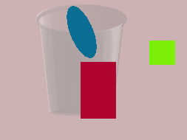 | Multiple random background objects, dynamically changing | Crowded kitchen, living room, or workspace
Table 7: Overview of the four testing conditions used to evaluate detection performance under varied environments.

2.4 Reinforcement Learning Framework
RL was used to adaptively control force application by the fingers of the hand to the object, based on force sensor feedback (58,16), to strike a balance between maintaining a stable grip and minimising total force usage. Three candidate agents, Proximal Policy Optimisation (PPO) (59), Soft Actor-Critic (SAC) (60) and Twin-Delayed Deep Deterministic Policy Gradient (TD3) (61), were considered to train the hand, summarised in Table 8.
Algorithm | Learning Approach | Primary Benefit | Recommended Use Experiment
Proximal Policy Optimisation (PPO) (59) | Gradually refines its policy using recent trial data | Smooth and reliable updates, reducing erratic behaviour | General purpose control where stability is most important
Soft Actor-Critic (SAC) (60) | Balances trial of new actions with reinforcement of successful ones | Rapid adaptation to changing conditions and robustness to uncertainty | Scenarios requiring fast learning and exploration
Twin-Delayed Deep Deterministic Policy Gradient (TD3) (61) | Employs dual value estimators to check each other’s judgments | Prevents overly optimistic decisions for more consistent performance | Tasks demanding precise, steady control
Table 8: Summary comparison of the three-candidate reinforcement‐learning algorithms, detailing each method’s learning strategy, main benefit, and the scenarios for which it is best suited.
PPO was chosen to for its proven stable performance in control tasks in robotics, exemplified by Kokila et al who used PPO to train a doorhandle detecting robot to open doors (62). It is easier to tune compared to SAC and TD3, making it an easier model to implement quickly. The hand was trained in a custom OpenAI Gym (v0.26.2) environment. This standard RL wrapper uses its reset and step interface to structure each simulation step into a repeatable loop of observation, action, and reward (63). This environment was integrated with Stable-baselines3 release 2.4.1, an industry-standard library for RL (64). The PPO algorithm used the Stable-Baselines3 default hyperparameters to reduce the prototype’s initial complexity, ensuring easier reproducibility. These defaults balance stability and performance for continuous control tasks, as documented in the PPO parameter specifications (65). Model evaluation was done through checkpointing and TensorBoard logging, and was tuned till the best learning trend was observed.
The reward function used quantifies errors by penalising actions that lead to excessive force or inadequate grip stability and praising low force and slip. Two models were trained, aiming to gradually introduce complexity through a method called Curriculum Learning. This starts with easier tasks and progressively increases difficulty, improving learning. This approach is supported by Bengio et al, who demonstrated that structured training progressions can improve performance on complex robotics tasks (66). Firstly, the agent was trained on a single experiment to master the simple task of grasping an empty plastic cup. Then it was trained on all six experiment types at random.
In both models, the reward function is defined as follows. During each step, the immediate reward $(R_{step})$ was computed as:
$$\begin{aligned}R_{step} = -\left(ω_{force}×F_{total}\right)\#\left(1\right)\end{aligned}$$
Where:
- $ω_{force}$ is a weighting factor that scales the force penalty.
- $F_{total}$ is the total average contact force measured across all the joints during the grasp, measured in Newtons (N).
At the end of an episode, after the shake test, object displacement, or slip $(Δ)$ ,was calculated and an additional penalty was applied:
$$\begin{aligned}Slip Penalty = α×Δ\#\left(2\right)\end{aligned}$$
Where:
- $Δ$ denotes slip, measured in meters, between the objects initial and final position before and after the test (m).
- $α$ is the weight applied to the slip penalty.
The total reward is then adjusted by subtracting the slip penalty and adding bonus rewards if performance exceeds baseline metrics:
$$\begin{aligned}R_{final}=R_{step}-\left(α×Δ\right)+B\#\left(3\right)\end{aligned}$$
$B$ represents bonus reward added if the performance surpasses the baseline metrics (i.e. if the force and the slip are less than a baseline values shown on the unenhanced hand). It is defined as:
$$\begin{aligned}B = B_{Force}+B_{Δ}\#\left(4\right)\end{aligned}$$
Where
- If $F_{total}< F_{Baseline}$ from the Non-RL model, $B_{Force}$ reward is given.
- If $Δ < Δ_{Baseline}$ from the Non-RL model, a $B_{Δ}$ reward is given.
Weights and bonus rewards were empirically adjusted based on observed training performance, like the method used by Savevska et al (67). Final weights for each model are reported in Table 9.
Parameter | Value for model single | Value for model all
$$ω_{force}$$ | 1.0 | 0.1
$$α$$ | 20.0 | 100.0
$$F_{Baseline}$$ | 29.8353365 N | Scenario-specific
$$Δ_{Baseline}$$ | 0.003378328 m | Scenario-specific
$$B_{Force}$$ | 10.0 | 15.0
$$B_{Δ}$$ | 10.0 | 15.0
Table 9: Final reward function parameters for the two RL training regimes. The single experiment model uses a force weight $(ω_{force})$ of 1.0 and penalty scale $(α)$ of 20, whereas the all-experiments model applies a lower force weight (0.1) and higher penalty scale (100). Scenario specific baselines for contact force $(F_{Baseline})$ and displacement ${(Δ}_{Baseline})$ were drawn from the corresponding non RL hand trials, and bonus thresholds ${{(B}_{Force}, B}_{Δ})$ indicate the extra reward awarded for meeting or exceeding those criteria.
The final reward function for the single experiment design was:
$$\begin{aligned}R_{Final}=-\left(1.0×F_{total}\right)-\left(20.0×Δ\right)+B\#\left(5\right)\end{aligned}$$
For the all-experiment design, the reward function was extended to include additional terms that account for the variability across different object types, thereby promoting a policy that generalises well across all conditions. The reward function was:
$$\begin{aligned}R_{Final}=-\left(0.1×F_{total}\right)-\left(100.0×Δ\right)+B\#\left(6\right)\end{aligned}$$
The weights were adjusted in the all-experiments design to improve performance across all six conditions.
The two models were trained for 500,000 steps, a duration chosen to ensure stable grip control in line with simulation-to-real precedents (68,69). Training performance metrics were collected, shown on Figure’s A2 and A3, and the final model was evaluated against the non-RL enhanced hand over 30 grasping trials for each of the 6 experiments.

2.5 Evaluation Metrics and Statistical Analysis
CV performance was measured with accuracy, precision, recall, and an F1 score, explained on Table 10. Detection confidence and inference time were tracked as real-time metrics to assess the model’s robustness across the four environmental conditions. RL model training was assessed using episode reward, training loss, entropy, and episode length to track convergence and learning dynamics. The final grip performance was evaluated against the non-RL models performance using average grip force, reaction force distribution across the links, and the slip experienced by the drinking containers after the shake test.
Normality and homogeneity of variance were assessed with Shapiro–Wilk and Levene tests to guide the choice of statistical analyses, for which the real-time CV performance results failed. Though, the variances were comparable, leading to the use of a Kruskal–Wallis test (η²ₕ), followed by Dunn’s post-hoc pairwise comparisons, reporting effect sizes (r).
For the RL vs non-RL hand assessment, raw metrics and standard deviations were reported for comparison. The single experiment model showed normality but variances were significantly different, leading to the use of Welch’s t-test to evaluate performance of gripping force and force distribution. The slip metric found that the slip was not normally distributed, leading to the use of the Mann-Whitney U test. For the all-experiment model, normality was not observed overall, leading to the use of the Mann–Whitney U test to assess all metrics.
All tests were evaluated at the α=0.05 significance level, common practice for biomedical and machine learning research (70,71).

3 RESULTS

3.1 Computer Vision augmentation
The outcome of the YOLO-nano object detection model can be seen on Figure 10, which shows the confusion matrix of cup vs no-cup classifications from the image dataset. Table 10 summarises the evaluation metrics calculated from the confusion matrix.
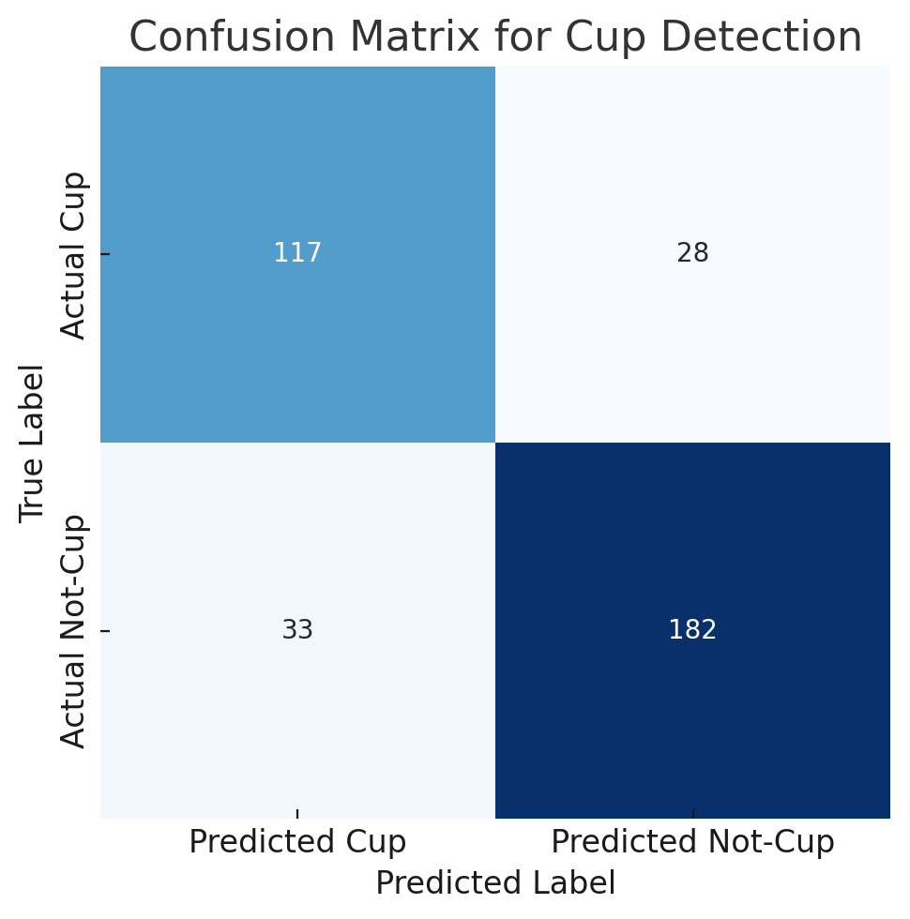
Figure 10: Confusion Matrix for Cup Detection, visually displaying the models predicted class label against the actual label. Boxes from top to bottom, left to right show the true positive (TP), false positive (FP), false negative (FN) and true negative (TN) values.
Metric | Formula | Score | Meaning
Accuracy | $$\frac{TP+TN}{TP+FP+TN+FN}$$ | 0.831 | Overall fraction of correct classifications (cups and non-cups combined).
Precision | $$\frac{TP}{TP+FP}$$ | 0.780 | Fraction of detections that were true cups (lower false alarm rate yields higher precision).
Recall | $$\frac{TP}{TP+FN}$$ | 0.807 | Fraction of actual cups detected by the model (captures sensitivity to finding all cups).
F1-Score | $$2*\frac{Precision*Recall}{Precision+Recall}$$ | 0.793 | Combined precision/recall performance (1.0 is perfect detection accuracy).
Table 10: Evaluation of the object detection model on the image test set. Reported metrics are: accuracy (83.1%), precision (78.0%), recall (80.7%) and F1 score (79.3%). Here, precision measures the proportion of correct positive predictions, recall quantifies the fraction of true objects detected, and the F1 score is their harmonic mean.
Table 11 reports the model’s inference time under each visual. The cylindrical power grip was correctly executed in all trials, meaning 100% accurate identification of the cup. A lower inference time indicates faster detection, meaning faster vision-to-grasp determination. Under optimal lighting (baseline condition), YOLO-nano processed frames in 0.088s on average. Introducing visual challenges (low lighting, occlusion, cluttered background) impacted performance as confidence tended to decrease and inference time increase. Figure 1 and Figure 12 illustrate these trends with bar charts. The Kruskal–Wallis test confirmed a significant difference in performance across the four conditions (p < 0.05), prompting post-hoc pairwise Dunn tests to identify specific pairwise differences. Table 12 summarises these post-hoc results for detection precision and Table 13 for inference time. These real-time detection results establish a reliable baseline, which we then initiate the RL grip controller.
Condition | n | Inference Time (s) | 95 % CI (s) | Raw Confidence | 95 % CI
Baseline | 30 | 0.08825 ± 0.00459 | [0.08658 – 0.08992] | 0.90680 ± 0.00000 | [0.90680 – 0.90680]
Clutter | 30 | 0.08355 ± 0.00470 | [0.08185 – 0.08526] | 0.80264 ± 0.12914 | [0.75199 – 0.85330]
Occlusion | 30 | 0.08490 ± 0.00269 | [0.08392 – 0.08588] | 0.89810 ± 0.00000 | [0.89810 – 0.89810]
Poor Light | 30 | 0.08449 ± 0.00423 | [0.08295 – 0.08603] | 0.90040 ± 0.00000 | [0.90040 – 0.90040]
Overall average | 120 | 0.08530 ± 0.00413 | [0.08456 – 0.08604 | 0.87699 ± 0.06457 | [0.86544 – 0.88854]
Table 11: Realtime object detection performance across four simulated conditions (n = 30 per condition) and an average over all. Shows mean inference time ± Standard Deviation (SD) with 95 % confidence intervals, alongside mean raw detection confidence ± SD with their 95 % confidence intervals.
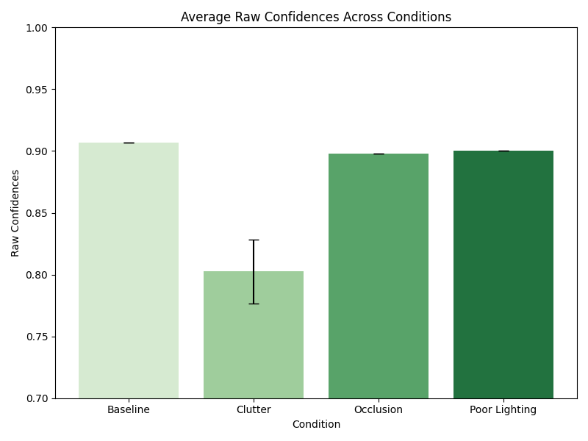
Figure 11: Comparison of detection confidence across the four simulated conditions (n = 30 per condition; error bars ±1 SD)..
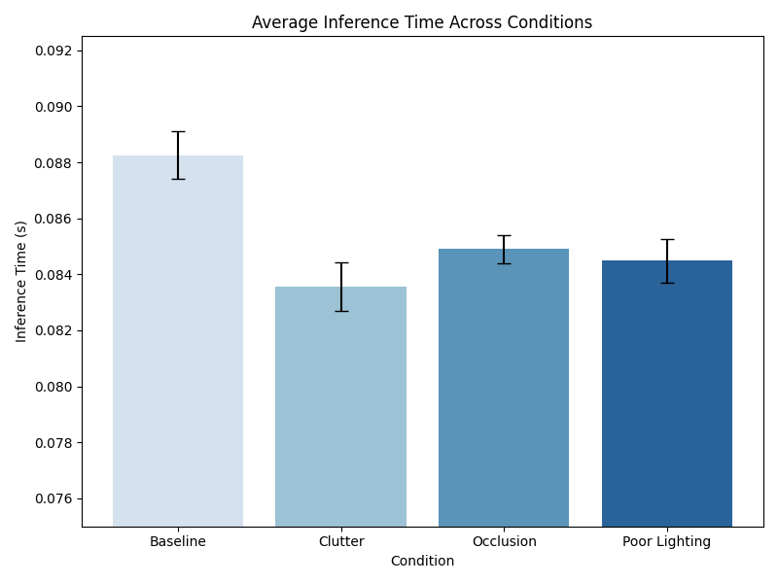
Figure 12: Comparison of inference time across the four simulated conditions (n = 30 per condition; error bars ±1 SD).
Comparison | Adjusted p value | Statistically significant? | Effect size r
Baseline vs Clutter | 2.9381 × 10⁻¹¹ | Yes | 0.8578
Clutter vs Occlusion | 5.3673 × 10⁻³ | Yes | 0.4130
Clutter vs Poor Light | 5.3673 × 10⁻³ | Yes | 0.4130
Table 12: Post hoc Dunn’s pairwise comparisons for detection confidence, rejecting H01 as there was a significant difference in the clutter condition compared to all others. The effect size r showed that there was high linear relationship between baseline and clutter, but the rest not as much. Kruskal–Wallis: H(3)=86.8101, p=1.0606 × 10⁻¹⁸, η²ₕ=0.7619, n=120.

Comparison | Adjusted p value | Statistically significant? | Effect size r
Baseline vs Clutter | 3.5313 × 10⁻³ | Yes | 0.4523
Baseline vs Occlusion | 2.4089 × 10⁻² | Yes | 0.3788
Baseline vs Poor Lighting | 3.3823 × 10⁻² | Yes | 0.3645
Clutter vs Occlusion | 1.0000 | No | 0.1787
Clutter vs Poor Lighting | 1.0000 | No | 0.1235
Occlusion vs Poor Lighting | 1.0000 | No | 0.0357
Table 13: Post-hoc Dunn’s pairwise comparisons for inference time, rejecting H₀₁ as there was a significant differences in the clutter condition compared to all others. The effect size r showed that there was overall some linear relationship between values, but they were low. Kruskal–Wallis: H(3)=15.3719, p=0.0015249, η²ₕ=0.1105, n=120.

3.2 Reinforcement Learning Model Performance and comparison with Non-AI enhanced prosthetic

3.2.1 Single-Experiment Model Performance
After training an initial run of the algorithm on one test environment, the plastic cup empty experiment, the performance between the RL and Non-RL hand was compared, with the force by displacement in Figure 13 and the distribution across links outlined in Figure 14. In all experiments the Mann-Whitney U test showed sufficient evidence to reject the null hypothesis, showing the RL hand as more efficient and more stable than its unenhanced counterpart. Figure 13 and 14, along with the data in Tables 14–15, confirm significantly lower force (p=0.024) and slip (p<0.0001). After demonstrating gains on a single cup, testing expanded to encompass all six.
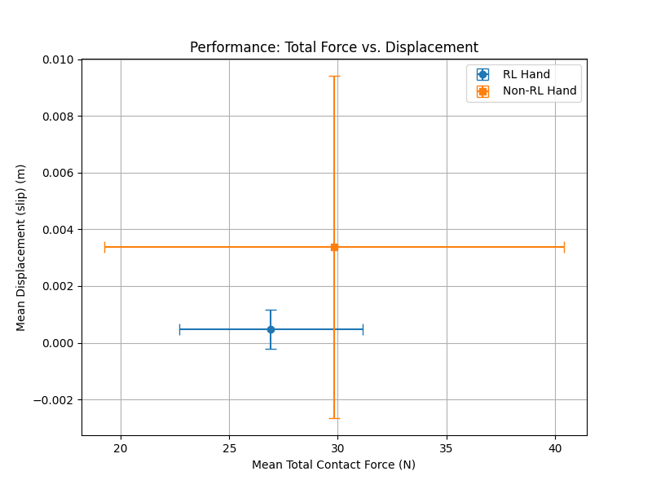
Figure 13: Mean total contact force versus mean slip for the RL trained (blue) and non RL baseline (orange) prosthetic hands during the single experiment empty‐plastic‐cup grasp. Error bars denote ±1 SD. The RL controller achieves both a lower average force and dramatically reduced slip, demonstrating a more efficient and stable grasp compared to the unenhanced hand.
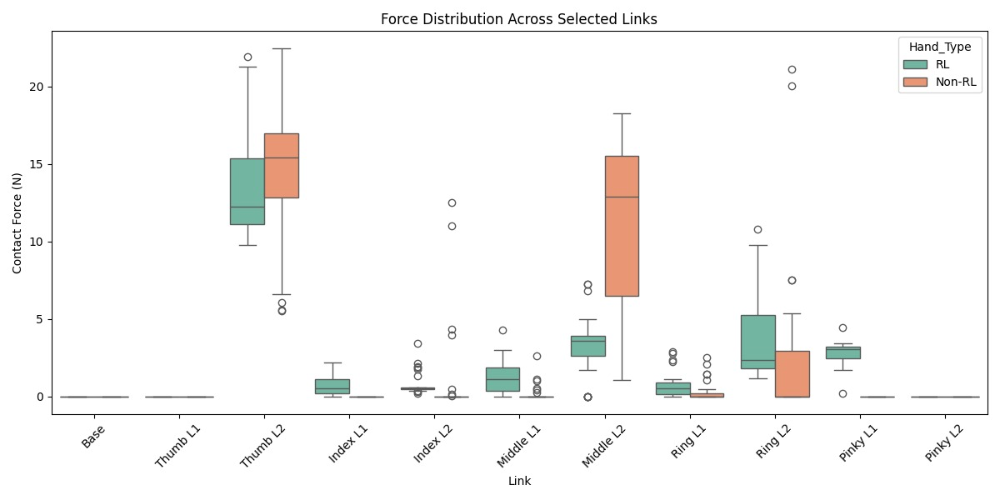
Figure 14: Distribution of contact forces across all 11 prosthetic hand links when grasping an empty plastic cup in the single‐experiment model. Boxplots compare the non RL baseline (orange) versus the RL trained controller (blue) at each sensor location. The RL policy markedly lowers median and peak forces, makes use of all the fingers, and tightens the interquartile ranges across most links, demonstrating a more uniform, stable grasp.

Metric | Unit | Non RL | RL | p value
Grip force | N | 29.84 ± 10.6 | 26.92 ± 4.24 | 0.0242
Slip | m | 0.00338 ± 0.00604 | 0.00047 ± 0.00069 | < 0.0001
Table 14: Single-experiment comparison (empty plastic cup) of grip force and slip between RL and Non-RL prosthetic hands (mean ± SD; p-values from Mann–Whitney U test). Both H₀₃ and H₀₄ were rejected.
Unit | Std. Dev. (Non-RL) | Std. Dev. (RL) | p-value
N | 1.53 | 0.72 | 0.0006
Table 15: Single-experiment comparison of force distribution across links of the hand (Standard Deviation between links ; p-values from Welch’s t-test). H₀₅ was rejected.

3.2.2 All-Experiments Model Performance
Figures 15 and 16 visualise the performance of the all-experiments model on an experiment-by-experiment basis. Tables 16 and 17 summarise its performance in each condition. All experiments showed significantly different performance between the RL and Non-RL hands in terms of gripping strength, rejecting the null hypothesis. However, the same could not be said in terms of the slip and force distribution. The null hypothesis for slip could not be rejected for the glass-full and ceramic-cup-full conditions. It could neither be rejected for force distribution in the glass full condition. Table 18 provides an at-a-glance summary of performance.
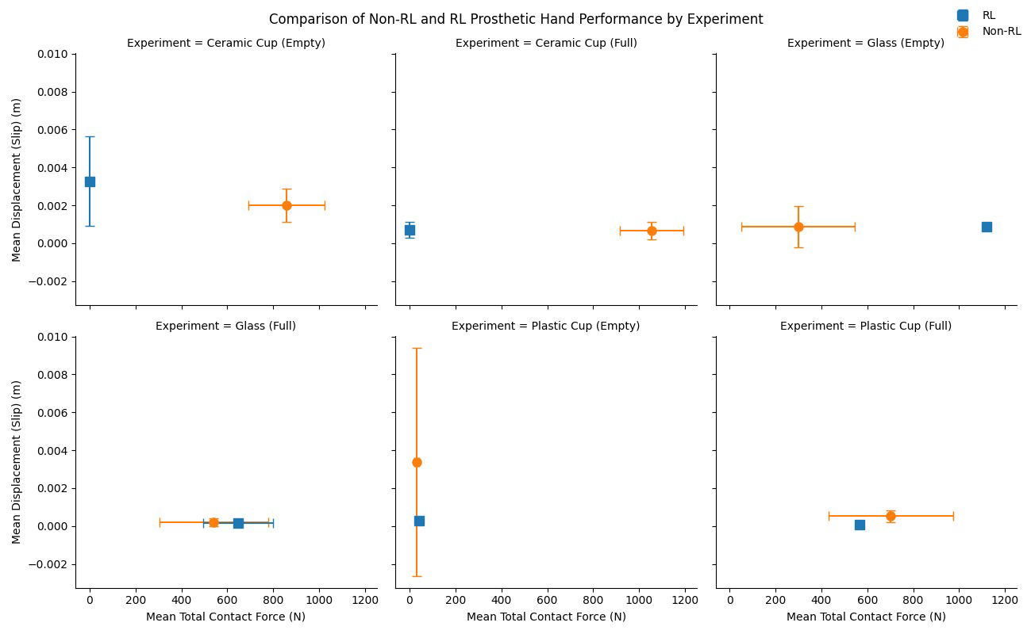
Figure 15: Comparison of mean slip (y axis) versus mean total contact force (x axis) for RL enhanced (blue) and non RL (orange) prosthetic hands across six grasping scenarios. Error bars show ±1 SD. In most experiments, the RL controller shifts the point downwards (lower slip) and/or to the left (lower force), indicating some more stable and efficient grasps, with lower deviations from the mean for both contact force and displacement overall. An outlier of 1120 N appeared in the Glass (Empty) condition, but was kept in the analysis as it reflected the genuine agent behaviour.
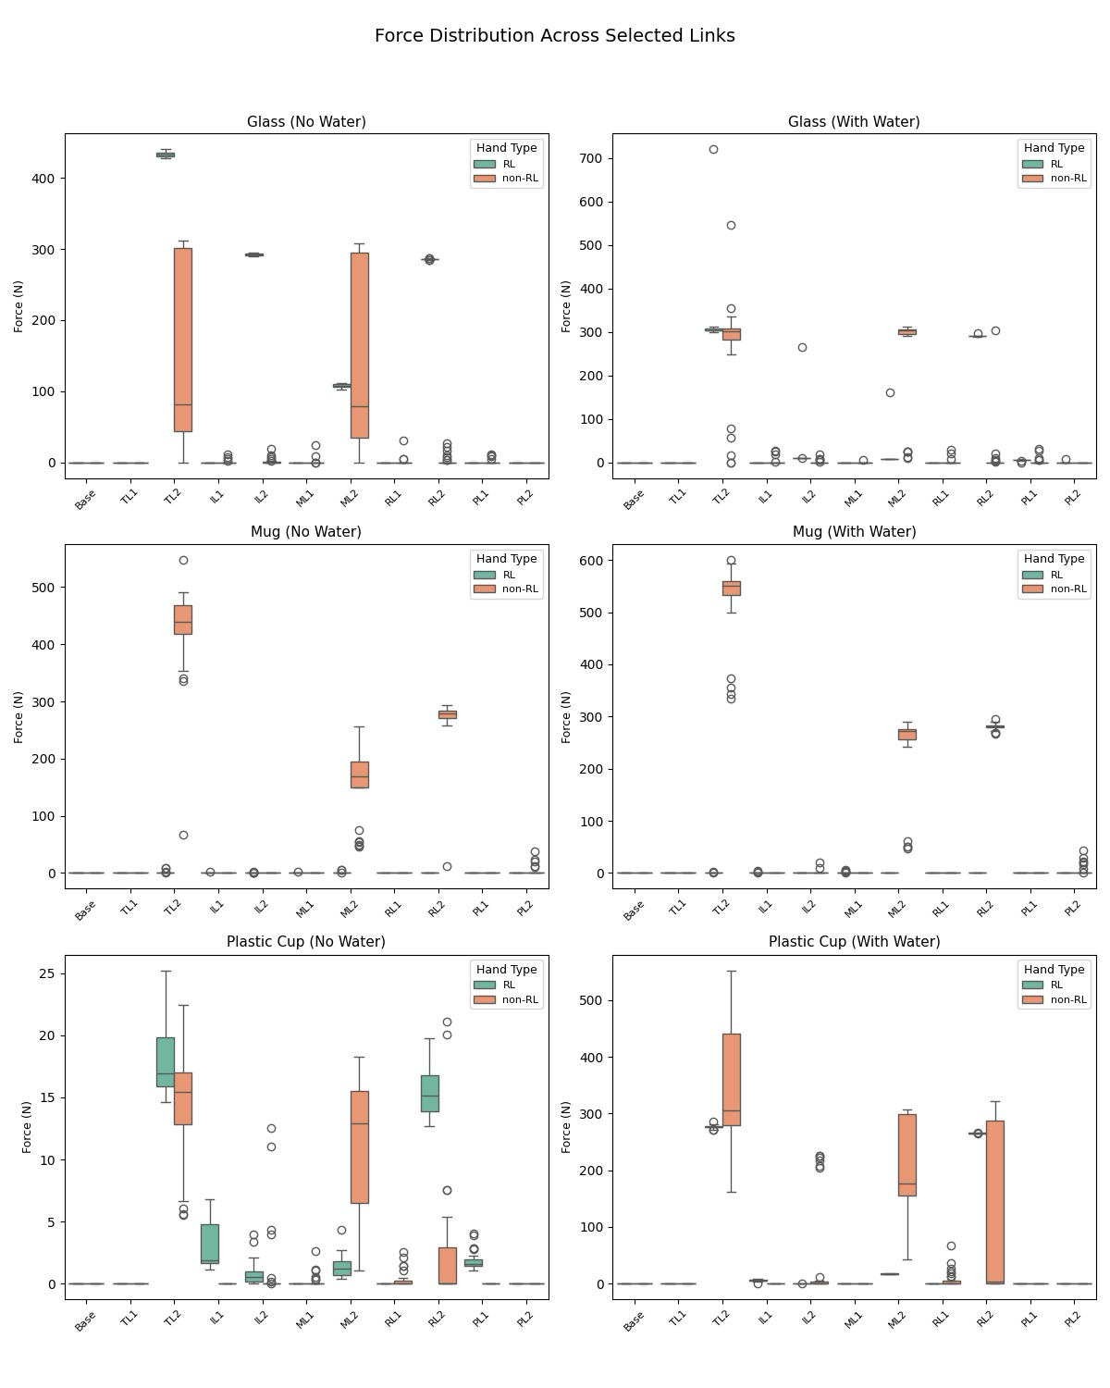
Figure 16: Force distribution across individual prosthetic hand links for RL-enhanced (blue) versus non-RL (orange) control when grasping three object types under empty (No Water) and full (With Water) conditions. Rows correspond to a glass, a ceramic mug, and a plastic cup. Each boxplot represents the contact force measured at each of the 11 links.

Object | Condition | Grip Force (N)  Non-RL | Grip Force (N)  RL | p-value | Slip (m) Non-RL | Slip (m) RL | p-value
Plastic Cup | Empty | 29.8 ± 10.6 | 26.9 ± 4.24 | 2.42 × 10⁻² | 0.00338 ± 0.00604 | 0.00047 ± 0.00069 | < 1 × 10⁻⁴
Plastic Cup | Full | 703 ± 271 | 565 ± 3.91 | 1.52 × 10⁻³ | 0.000527 ± 0.000309 | 0.0000658 ± 0.00000185 | 3.34 × 10⁻¹¹
Glass | Empty | 300 ± 247 | 1120 ± 5.06 | 3.02 × 10⁻¹¹ | 0.000888 ± 0.00109 | 0.000885 ± 0.000030 | 3.99 × 10⁻⁴
Glass | Full | 542 ± 237 | 647 ± 152 | 1.04 × 10⁻⁴ | 0.000200 ± 0.000212 | 0.000143 ± 0.000035 | 0.865
Ceramic mug | Empty | 857 ± 166 | 1.39 ± 2.43 | 2.11 × 10⁻¹¹ | 0.00199 ± 0.000882 | 0.00328 ± 0.00235 | 3.15 × 10⁻²
Ceramic mug | Full | 1050 ± 138 | 0.815 ± 1.65 | 1.10 × 10⁻¹¹ | 0.000660 ± 0.000462 | 0.000712 ± 0.000426 | 0.492
Table 16: RL vs Non-RL prosthetic hand performance (mean ± SD; p-values from Mann–Whitney U test). H₀₃ was rejected for all trials. H₀₄ was rejected for all trials apart from for the ceramic-mug full condition and the glass-full condition.
Object Type | Condition | Std. Dev. (Non-RL) | Std. Dev. (RL) | p-value
Plastic Cup | Empty | 1.53 | 0.686 | 0.017
Plastic Cup | Full | 32.7 | 0.533 | 3.99E-04
Glass | Empty | 41 | 0.582 | 3.02E-11
Glass | Full | 37 | 16.8 | 0.34
Ceramic Cup (Mug) | Empty | 22.7 | 0.587 | 2.11E-11
Ceramic Cup (Mug) | Full | 17.8 | 0.401 | 1.10E-11
Table 17: Force Distribution (Standard Deviation; p-values from Mann-Whitney U test). H₀₅ was rejected for every condition apart from the glass full condition.

Object | Fill | Grip-force Reduction (%) | Slip Reduction(%) | SD Force distribution Reduction (%)
Plastic cup | Empty | 9.7% | 86.1% | 55.2 %
Plastic cup | Full | 19.6% | 87.5% | 98.4 %
Glass | Empty | -273.3% | 0.3% | 99.6 %
Glass | Full | -19.3% | 28.5% | 54.6 %
Ceramic mug | Empty | 99.8% | -6% | 97.4 %
Ceramic mug | Full | 99.9% | -7.9% | 97.7 %
Overall | - | 32.2% | 27.3% | 87.2%
Table 18: Summary table of RL hand’s improvements in. to 1 decimal place. At a glance, the hand does overall improve in performance compared to the unenhanced hand, particularly in distributing force more evenly across links.

4 DISCUSSION
This work evaluates the novel vision–RL pipeline. Its key outcomes and limitations are discussed before situating the findings within state-of-the-art systems to underscore its impact.

4.1 Computer Vision Algorithm

4.1.1 Key Outcomes and Limitations
Although the results reject the null hypothesis, the metrics still establish a solid prototype baseline and foundation for future work. The slightly higher recall (81%) compared to precision (78%) indicates a trend toward detecting, and therefore grasping, cups, even at the cost of false alarms. This is better for assistive grasping where a missed object is more disruptive than a pointless grasp. The prototype still relies on a single-object dataset and synthetic backdrops, limiting realism. Though reasonable on the surface, an accuracy of 83% and 80% F1-score still means one in five detections cause a misfire, meaning for every 30 cup interactions there are six failed grasps, a frustration that could raise abandonment rates. Moreover, the image lacks key geometric cues like size and distance, which depth or multi-view vision could provide. The next goal is to raise the metrics, so the hand grasps only when a correct object is detected.
Although this is in simulation, real-time results are encouraging, with 88% confidence and 0.09s average inference across the conditions, well below the 0.25s average human visual reflex (72). Inference ran slightly faster in cluttered scenes, possibly due to early termination of the detection, explaining lower-confidence detections. This may have happened because the cup was blending in with similar looking shapes, such as cylinders, so only one low-confidence proposal cleared the threshold. The model’s robustness to cluttered environments must be improved to ensure accurate detection, as these setting are common in real life.

4.1.2 Context Within the State-of-the- Art and Future Work
Compared to another robotic grasp-vision system, Song et al reach 98 % accuracy with an inference time of 0.032 s on wooden blocks by tuning a YOLOv5 model and exploiting depth information from a RealSense camera (73). Their depth-assisted numbers mark the best possible outcome. This model is slower and 15 % less accurate but is the first to deliver real-time raw-image object detection on minimal hardware with the explicit aim of feeding into an RL-grip controller.
Ghazaei et al on grasp classification for myoelectric hands, report an 85 % accuracy at a latency of 0.081 s on grasp-type classification and 88 % task success at 0.15s latency with amputees (74). My detector has an 83.1% accuracy, and an average detection confidence of 87.7 % at 0.085 s inference. Though the vision tasks differ, object detection to a grasp type versus classifying a grasp, the near-matching accuracy and latency suggest this detector could supply grasp planners with timely, reliable cup locations, potentially shortening the overall perception-to-action loop if integrated with Ghazaei’s pipeline.
To boost data realism, training will be extended to richer, simulated kitchen scenes, though this will demand more advanced 3D-modelling expertise. Growing the object set and grasp range would improve evaluation by introducing distinct items to identify, showing how accurately it recognises each one and assigns the appropriate grasp.
Two immediate upgrades, inspired by Song et al’s depth-assisted system idea, is using the depth data from the PyBullet camera into a custom YOLO model trained in simulator on custom life-like objects, and similarly prune the model to drop unneeded layers, though this would require a deeper knowledge of how they work. Further gains should come from expanding the dataset and tuning accuracy and confidence thresholds to lower false negatives without increasing false positives.
Integrating a lightweight segmentation model alongside the object detection, (75) like Wang et al’s approach (76), would make for pixel-accurate masks in clutter, improving the model’s overall ability to see and distinguish objects.
Finally, running tests by implementing the detector on a real ability hand and replicating Ghazaei’s real-life user trials to confirm if it does indeed improve the user experience.

4.2 Reinforcement Learning Algorithm

4.2.1 Key Outcomes and Limitations
In single‐object tests, the RL agent significantly outperformed the non‐RL baseline, achieving lower grip force, reduced slip, and a more uniform force distribution, thereby positively supporting alternative hypotheses 3, 4, and 5. However, in the multi‐scenario experiments, while the alternative hypotheses hold, the findings are more ambiguous.
The RL policy often went for “safe” strategies, applying 1120 N on the empty glass versus 300 N for the baseline (p≈3 × 10⁻¹¹) without reducing slip (≈0.00089 m vs. 0.000888 m, p=0.399), or cutting force on the ceramic mug from 857 N to just 1.4 N (p≈2 × 10⁻¹¹) while slip rose from 0.00199 m to 0.00328 m (p≈0.0315), exposing a skewed force–slip trade-off, known as reward hacking, where an agent exploits flaws in the reward function to achieve higher rewards without actually accomplishing the intended task (77).
Both the standard and RL policies still yield sub-millimetre slip and clinically negligible displacements (< 3 mm) on the tested objects, though formal clinical slip thresholds for upper-limb prostheses are undefined. In more complex or irregular geometries, I anticipate slip will increase, underscoring the need for richer training diversity or lightweight additional cues.
Human finger forces also should only average 8–11 N per finger and rarely exceed 25–35 N in daily tasks (78,79), yet the simulation yields hundreds of newtons per link and over 1 kilonewton total, an order-of-magnitude overestimate caused by an uncalibrated URDF contact parameters and untuned physics settings.
The model needs to be consistent if it is to grab different kinds of objects autonomously and reduce user cognitive effort. The simulation also needs to reflect more realistic unit ranges.

4.2.2 Context Within the State-of-the- Art and Future work
Basumatary et al.’s SAC-based robotic-reflex hand using tactile sensors and trained under randomised friction, weight, and stiffness conditions, achieved a 56 % improvement reducing slip-over a non-randomised agent in a shaking test (50). In comparison, this controller, which relies solely on per-link force feedback (the same limited feedback prosthetics give today), managed a 27% overall slip reduction across all scenarios. This is less than half of the effectivity of Basumatary’s robot hand, so improving this effectiveness is essential.
To address these gaps, three key strategies can be deployed. First, Basumatary’s recent work adds an adaptive sliding-mode controller that intervenes when unexpected slippage or force perturbations arise, decoupling nominal RL gripping from reflex‐style slip correction (80). Implementing a similar dual-controller design, one module for initial grasping and another for real-time slip adjustment, offers a clear path to bolster the hand’s resilience in dynamic environments.
Second, Puang et al.’s transformer-based policy for a robotic gripper, balancing “no-slip” versus “low-force” via a tuneable reward, achieved 95–99 % success in simulation and 100 % stable real-world grasps in trials with only ~2.4 re-grasps per lift (81). Compared to a standard CNN based RL policy, the transformer reduced excessive gripping force by 11% over 30 trials. Future work will explore using a transformer-style self-attention module to map sequential force readings and past actions. By giving the RL agent a temporal memory of how slip evolves, this architecture should let the prosthetic hand learn the balance between stability and gentleness with less manual reward-tuning, rather than relying on single-step observations alone.
Finally, Kleijin et al. show that a more gradual curriculum-based approach for the RL agent, progressively introducing grasp tasks with hierarchical, object-conditioned reward shaping, yields superior stability and efficiency across varied objects (82). A more gradual introduction of the six cup-grasp scenarios gradually with tailor rewards, starting with strong slip penalties, then shifting to force minimisation plus a force-spike penalty, would foster more uniformly efficient, robust grasps in future iterations.
To address the extreme force readings, real prosthetic force sensors could be calibrated to identify true friction, damping, and inertia coefficients. Then the simulation model’s parameters could be updated so simulated forces align accurately with human biomechanical ranges, reflecting realistic griping mechanics
To enable a more direct comparison with real-hand capabilities, the variety of 3D-object and associated grasp types should be expanded to include pinch, spherical, lateral, tripod and extension grasps. This would render the hand suitable for testing under the SHAP protocol used by Bouwsema et al, facilitating a standardised comparison with both human and myoelectric hands (19).

5 CONCLUSIONS AND A VISION OF THE FUTURE
This project introduces the first simulated prosthetic hand combining object detection with a force-feedback RL controller to achieve autonomous, naturalistic grasping. The results demonstrate that real-time object detection can successfully guide the hand, and reinforcement learning-based grip optimisation can improve object gripping. This lays the foundation for more adaptive prosthetic hand control. While limited to a simulated environment, this Vision-RL system is a step toward easier, intuitive and natural to use bionic hands.
Looking ahead, a unified control pipeline could fuse CV information and RL. This could be in the form of object detections being encoded as compact geometric feature vectors and fed into a vision-conditioned PPO policy, as explored in prior vision-guided robotic grasping work (83,84). Such a policy could better tailor the prosthetic’s grasp to each object’s shape and orientation, improving stability and efficiency, lowering the learning curve for bionic-hand use further. Eventually, this controller could integrate with a shared-control myoelectric prosthetic, blending the user’s intent with autonomous grip adaptation. By combining computer vision, reinforcement learning, and myoelectric control into a single adaptive loop, bionic prosthetic hands can evolve from assistive tools to true, functional replacement hands.

6 SUSTAINABILITY STATEMENT
Sustainability demands life-cycle accountability, from raw-material extraction and operational energy to end-of-life disposal, so that technological innovation stays within environmentally friendly boundaries and upholds social equity. Applying this perspective to research favours digital-first methods, low- carbon-footprint workflows and early planning for energy-efficient hardware deployment.
This project minimised environmental impact by using only personal computing hardware and digital simulations. By eliminating physical prototyping, it produced no material waste and reduced energy consumption. The low-cost, fully digital approach exemplifies a commitment to sustainable, socially responsible innovation. When the system is ported to a real prosthesis, a priority will be profiling the AI’s power draw and optimising it to extend battery life.

7 EQUALITY, DIVERSITY AND INCLUSION STATEMENT
A rigorous grasp of equality, diversity and inclusion recognises that systemic power imbalances, not individual bias alone, shape access to resources and representation. Consequently, effective EDI practice must break structural barriers, embed measurable accountability across policy, data and design choices, and continuously adapt to evolving social contexts.
This project demonstrates a commitment to equality, diversity, and inclusion by attempting to make prosthetic hands more adaptable to all uses and users. This addresses diverse user needs across varied settings, ensuring individuals with upper-limb amputations from different backgrounds can benefit equally. The low-cost, simulation-only approach reduces barriers for reproducing work on advancing bionic technology, promoting equitable access to research.
Future work, once the device is fully implemented, will include trial sessions with amputees of diverse ages, genders and cultures. Code will be released to the public free-of-charge via GitHub, ensuring equitable access and usability across researchers from different socioeconomic background.

8 ACKNOWLEDGEMENTS
Thank you to my supervisor Dr. Peter Snow for supervising this project I designed myself. I would also like to thank my personal tutor for the helpful feedbac. Finally, I would like to thank my family for supporting me throughout my degree. GenAI (ChatGPT) was used as an assistive role in helping debug code and to aid in formulating ideas during the planning phase.

9 REFERENCES
- Cordella F, Ciancio AL, Sacchetti R, Davalli A, Cutti AG, Guglielmelli E, et al. Literature Review on Needs of Upper Limb Prosthesis Users. Frontiers in Neuroscience. 2016 May 12;10.
- Clinical Commissioning Policy Multi-grip prosthetic hand (all ages) (2009) [220801P] Commissioning position [Internet]. Available from: https://www.england.nhs.uk/wp-content/uploads/2022/09/2009-clinicial-comm-policy-multi-grip-prosthetic-hand-all-ages-1.pdf
- Engdahl SM, Christie BP, Kelly B, Davis A, Chestek CA, Gates DH. Surveying the interest of individuals with upper limb loss in novel prosthetic control techniques. Journal of NeuroEngineering and Rehabilitation. 2015 Jun 13;12(1).
- Smith A. Pliny, Natural History, 7 (b) [Internet]. Attalus.org. 2025. Available from: https://www.attalus.org/translate/pliny_hn7b.html
- Nagaraja VH, da Ponte Lopes J, Bergmann JHM. Reimagining Prosthetic Control: A Novel Body-Powered Prosthetic System for Simultaneous Control and Actuation. Prosthesis. 2022 Jul 29;4(3):394–413.
- Hashim NA, Abd Razak NA bin, Gholizadeh H, Osman NAA. Analysis of voluntary opening Ottobock Hook and Hosmer Hook for upper limb prosthetics: a preliminary study. Biomedical Engineering / Biomedizinische Technik. 2017 Aug 28;62(4):447–54.
- Figure 5. A typical body-powered upper limb prosthesis. [Internet]. ResearchGate. 2024. Available from: https://www.researchgate.net/figure/A-typical-body-powered-upper-limb-prosthesis_fig5_337261018
- Smit G, Bongers RM, Van der Sluis CK, Plettenburg DH. Efficiency of voluntary opening hand and hook prosthetic devices: 24 years of development? The Journal of Rehabilitation Research and Development. 2012;49(4):523.
- Upper Limb Prosthetic Terminal Devices: Hands Versus Hooks | O&P Virtual Library [Internet]. www.oandplibrary.org. Available from: http://www.oandplibrary.org/cpo/1986_02_057.asp
- Swartz AQ, Turner K, Miller L, Kuiken T. Custom, rapid prototype thumb prosthesis for partial-hand amputation: A case report. Prosthetics and Orthotics International. 2017 Jun 22;42(2):187–90.
- Hichert M, Vardy AN, Plettenburg D. Fatigue-free operation of most body-powered prostheses not feasible for majority of users with trans-radial deficiency. Prosthetics & Orthotics International. 2018 Feb;42(1):84–92.
- SHERMAN ED. A RUSSIAN BIOELECTRIC-CONTROLLED PROSTHESIS: REPORT OF A RESEARCH TEAM FROM THE REHABILITATION INSTITUTE OF MONTREAL. Canadian Medical Association journal [Internet]. 1964 Dec;91(24):1268–70. Available from: https://pubmed.ncbi.nlm.nih.gov/14226106/
- PSYONIC. Ability Hand [Internet]. PSYONIC. Available from: https://www.psyonic.io/ability-hand
- Crandall RC, Tomhave W. Pediatric unilateral below-elbow amputees: retrospective analysis of 34 patients given multiple prosthetic options. Journal of pediatric orthopedics [Internet]. 2002;22(3):380–3. Available from: https://pubmed.ncbi.nlm.nih.gov/11961460/
- Biddiss EA, Chau TT. Upper limb prosthesis use and abandonment: A survey of the last 25 years. Prosthetics and Orthotics International. 2007 Sep;31(3):236–57.
- Verma K. Ability Hand – a revolution in bionic technology [Internet]. Interesting Engineering. 2023 [cited 2025 May 5]. Available from: https://interestingengineering.com/ces-2023/ability-hand-revolution-bionic-technology?group=test_a
- Chen Z, Min H, Wang D, Xia Z, Sun F, Fang B. A Review of Myoelectric Control for Prosthetic Hand Manipulation. Biomimetics [Internet]. 2023 Jul 1;8(3):328. Available from: https://www.mdpi.com/2313-7673/8/3/328
- Wang B, Li J, Hargrove L, Kamavuako EN. Unravelling Influence Factors in Pattern Recognition Myoelectric Control Systems: The Impact of Limb Positions and Electrode Shifts. Sensors. 2024 Jul 25;24(15):4840–0.
- Bouwsema H, van der Sluis CK, Bongers RM. Changes in performance over time while learning to use a myoelectric prosthesis. Journal of NeuroEngineering and Rehabilitation. 2014;11(1):16.
- Mouchoux J, Bravo-Cabrera MA, Dosen S, Schilling AF, Markovic M. Impact of Shared Control Modalities on Performance and Usability of Semi-autonomous Prostheses. Frontiers in Neurorobotics. 2021 Dec 17;15.
- Tawfik M, Baqer I, Abdulsahib A. Grasping Force Controlling by Slip Detection for Specific Artificial Hand (ottobock 8E37). Engineering and Technology Journal. 2018 Sep 25;36(9A):979–84.
- van der Riet D, Stopforth R, Bright G, Diegel O. An overview and comparison of upper limb prosthetics [Internet]. IEEE Xplore. 2013. p. 1–8. Available from: https://ieeexplore.ieee.org/abstract/document/6757590
- Khin PM, Low JH, Ang MH, Yeow CH. Development and Grasp Stability Estimation of Sensorized Soft Robotic Hand. Frontiers in Robotics and AI. 2021 Mar 31;8.
- Fabio Morbidi, Devigne L, Catalin Stefan Teodorescu, Bastien Fraudet, Leblong E, Carlson T, et al. Assistive Robotic Technologies for Next-Generation Smart Wheelchairs: Codesign and Modularity to Improve Users’ Quality of Life. IEEE Robotics & Automation Magazine. 2023 Mar 1;30(1):24–35.
- Carlson T. Towards equitable shared control. at - Automatisierungstechnik. 2024 Nov 28;72(12):1112–20.
- Zhang B, Holloway C, Carlson T. Reinforcement Learning Based Shared Control Navigation [Internet]. [cited 2025 May 5]. Available from: https://discovery.ucl.ac.uk/id/eprint/10190666/1/SMC23_ACCEPTED.pdf
- artificial intelligence shared control prosthetic hand - Search Results - PubMed [Internet]. PubMed. 2015 [cited 2025 May 5]. Available from: https://pubmed.ncbi.nlm.nih.gov/?term=+artificial+intelligence+shared+control+prosthetic+hand
- Farshad Khadivar, Mendez V, Gaspar C, Iason Batzianoulis, Billard A, Silvestro Micera. EMG-driven shared human-robot compliant control for in-hand object manipulation in hand prostheses. Journal of Neural Engineering. 2022 Dec 1;19(6):066024–4.
- AI in Healthcare Market Size, Trends & Forecast 2025-2035 [Internet]. Futuremarketinsights.com. 2025. Available from: https://www.futuremarketinsights.com/reports/artificial-intelligence-in-healthcare-market
- Machine Learning - an overview | ScienceDirect Topics [Internet]. Sciencedirect.com. 2016. Available from: https://www.sciencedirect.com/topics/computer-science/machine-learning
- Computer Vision - an overview | ScienceDirect Topics [Internet]. www.sciencedirect.com. Available from: https://www.sciencedirect.com/topics/computer-science/computer-vision
- Yamashita R, Nishio M, Do RKG, Togashi K. Convolutional Neural networks: an Overview and Application in Radiology. Insights into Imaging [Internet]. 2018 Jun 22;9(4):611–29. Available from: https://insightsimaging.springeropen.com/articles/10.1007/s13244-018-0639-9
- Baxter D, Snow P, Loureiro R, Mokawem M, Hawkins B, Yordanov D. OP19 The potential role of computer vision in endoscopic spinal surgery. Oral Presentations [Internet]. 2024 Sep 1 [cited 2025 May 5];A6.1-A6. Available from: https://sit.bmj.com/content/6/Suppl_1/A6.1
- Baxter D, Snow P, Loureiro R, Mokawem M, Hawkins B, Ziqi Zhang. (2025). Real Time Object Detection and Image Segmentation for Endoscopic Spinal Surgery. Unpublished manuscript.
- Hand that sees offers new hope to amputees [Internet]. Press Office. Available from: https://www.ncl.ac.uk/press/articles/archive/2017/05/handthatsees/
- Glorennec P. Reinforcement Learning: an Overview [Internet]. Available from: https://citeseerx.ist.psu.edu/document?repid=rep1&type=pdf&doi=b373b0c6e3b4fef4ac0534965708fc382343f8dc
- Liu R, Nageotte F, Zanne P, de Mathelin M, Dresp-Langley B. Deep Reinforcement Learning for the Control of Robotic Manipulation: A Focussed Mini-Review. Robotics. 2021 Jan 24;10(1):22.
- prosthetic hand reinforcement learning - Search Results - PubMed [Internet]. PubMed. 2015 [cited 2025 May 5]. Available from: https://pubmed.ncbi.nlm.nih.gov/?term=prosthetic+hand+reinforcement+learning
- Jethro Odeyemi, Akinola Ogbeyemi, Wong K, Zhang W. On Automated Object Grasping for Intelligent Prosthetic Hands Using Machine Learning. Bioengineering. 2024 Jan 24;11(2):108–8.
- Pérez-González A, Jurado M, Sancho-Bru J, Vergara M, Andrés F. GRASP SELECTION FOR CYLINDRICAL OBJECTS [Internet]. [cited 2025 May 5]. Available from: https://esbiomech.org/papers/ESB_congress_2013/oral/S61.4-581.pdf
- PSYONIC releases Ability Hand for research users [Internet]. PSYONIC. Available from: https://www.psyonic.io/news/psyonic-releases-ability-hand-for-research-users
- MatWeb. Overview of materials for High Density Polyethylene (HDPE), Ultra High Molecular Weight [Internet]. www.matweb.com. 2024. Available from: https://www.matweb.com/search/datasheet_print.aspx?matguid=f9470672aa5549cb9c7b157677d02062
- Lorenz B, Krick BA, Rodriguez N, Sawyer WG, Persson BNJ. Static or breakloose friction for lubricated contacts: The role of surface roughness and dewetting. Journal of Physics: Condensed Matter [Internet]. 2013 Oct 16;25(44):445013. Available from: https://www.researchgate.net/publication/257888833_Static_or_breakloose_friction_for_lubricated_contacts_The_role_of_surface_roughness_and_dewetting
- Ceramic Glaze [Internet]. digitalfire.com. Available from: https://digitalfire.com/glossary/ceramic+glaze
- A Review of Nine Physics Engines for Reinforcement Learning Research [Internet]. Arxiv.org. 2023. Available from: https://arxiv.org/html/2407.08590v1
- dexsuite. dex-urdf/robots/hands/ability_hand/ability_hand_right_glb.urdf at main · dexsuite/dex-urdf [Internet]. GitHub. 2023 [cited 2025 May 5]. Available from: https://github.com/dexsuite/dex-urdf/blob/main/robots/hands/ability_hand/ability_hand_right_glb.urdf
- Ability Hand System [Internet]. www.spsco.com. Available from: https://www.spsco.com/ability-hand-system.html
- bulletphysics. bullet3/docs/pybullet_quickstartguide.pdf at master · bulletphysics/bullet3 [Internet]. GitHub. 2025 [cited 2025 May 5]. Available from: https://github.com/bulletphysics/bullet3/blob/master/docs/pybullet_quickstartguide.pdf
- Fletcher M. Problems in Design of Artificial Hands [Internet]. [cited 2025 May 7]. Available from: http://www.oandplibrary.org/op/pdf/1955_02_059.pdf.
- Reinforcement Learning-Based Bionic Reflex Control for Anthropomorphic Robotic Grasping exploiting Domain Randomization [Internet]. Arxiv.org. 2023 [cited 2025 May 5]. Available from: https://arxiv.org/html/2312.05023v1
- Memon MA, Ting H, Cheah JH, Thurasamy R, Chuah F, Cham TH. Sample size for survey research: Review and recommendations. Journal of Applied Structural Equation Modeling [Internet]. 2020 Jun;4(2):i–xx. Available from: https://jasemjournal.com/wp-content/uploads/2020/08/Memon-et-al_JASEM_-Editorial_V4_Iss2_June2020.pdf
- YOLOv11: An Overview of the Key Architectural Enhancements [Internet]. Arxiv.org. 2015 [cited 2025 May 5]. Available from: https://arxiv.org/html/2410.17725v1#S2
- Lin TY, Maire M, Belongie S, Bourdev L, Girshick R, Hays J, et al. Microsoft COCO: Common Objects in Context [Internet]. arXiv.org. 2014. Available from: https://arxiv.org/abs/1405.0312
- ConnectTheDots. Cups Dataset [Internet]. Roboflow. 2024 [cited 2025 May 5]. Available from: https://universe.roboflow.com/connectthedots/cups-6ylj2/browse?queryText=&pageSize=50&startingIndex=0&browseQuery=true
- Sivakumar M, Parthasarathy S, Thiyagarajan Padmapriya. Trade-off between training and testing ratio in machine learning for medical image processing. PeerJ Computer Science [Internet]. 2024 Sep 6;10:e2245–5. Available from: https://peerj.com/articles/cs-2245/#
- Ultralytics. YOLO11 [Internet]. Ultralytics.com. 2024. Available from: https://docs.ultralytics.com/models/yolo11/
- TurboSquid [Internet]. Turbosquid.com. 2024 [cited 2025 May 5]. Available from: https://www.turbosquid.com/3d-models/freecuppack-5-cups-fbx-blend-and-images-taken-in-ue4-1263156
- Akhtar A, Cornman J, Austin J, Bala D. Touch Feedback and Contact Reflexes Using the PSYONIC Ability Hand. Myoelectric Controls Symposium [Internet]. 2020 Jul 23; Available from: https://conferences.lib.unb.ca/index.php/mec/article/view/26/16
- Schulman J, Wolski F, Dhariwal P, Radford A, Openai O. Proximal Policy Optimization Algorithms [Internet]. 2017 Aug. Available from: https://arxiv.org/pdf/1707.06347
- Haarnoja T, Zhou A, Abbeel P, Levine S. Soft Actor-Critic: Off-Policy Maximum Entropy Deep Reinforcement Learning with a Stochastic Actor. arXiv:180101290 [cs, stat] [Internet]. 2018 Aug 8; Available from: https://arxiv.org/abs/1801.01290
- Fujimoto S, Van Hoof H, Meger D. Addressing Function Approximation Error in Actor-Critic Methods [Internet]. Available from: https://arxiv.org/pdf/1802.09477
- Kokila M, Amalredge G. Mobile Robotic Arm for Opening Doors Using Proximal Policy Optimization. Data Analytics and Artificial Intelligence. 2023 Feb 1;3(2):107–12.
- openai. Releases · openai/gym [Internet]. GitHub. 2022 [cited 2025 May 5]. Available from: https://github.com/openai/gym/releases
- Raffin A, Hill A, Gleave A, Kanervisto A, Ernestus M, Dormann N. Stable-Baselines3: Reliable Reinforcement Learning Implementations. Journal of Machine Learning Research [Internet]. 2021;22:1–8. Available from: https://www.jmlr.org/papers/volume22/20-1364/20-1364.pdf
- PPO — Stable Baselines3 1.4.1a3 documentation [Internet]. stable-baselines3.readthedocs.io. Available from: https://stable-baselines3.readthedocs.io/en/master/modules/ppo.html
- Bengio Y, Louradour J, Collobert R, Weston J. Curriculum learning. Proceedings of the 26th Annual International Conference on Machine Learning - ICML ’09. 2009;
- Savevska K, Ude A. Analysis of Cost Functions for Reinforcement Learning of Reaching Tasks in Humanoid Robots. Applied Sciences [Internet]. 2023 Dec 20 [cited 2025 May 5];14(1):39. Available from: https://www.mdpi.com/2076-3417/14/1/39
- Iyengar K, Sadati SMHadi, Bergeles C, Spurgeon S, Stoyanov D. Sim2Real Transfer of Reinforcement Learning for Concentric Tube Robots. IEEE Robotics and Automation Letters [Internet]. 2023 Oct [cited 2025 May 5];8(10):6147–54. Available from: https://discovery.ucl.ac.uk/id/eprint/10175097/2/Iyengar_Sim2Real%20Transfer%20of%20Reinforcement%20Learning%20for%20Concentric%20Tube%20Robots_AAM2.pdf
- Ibarz J, Tan J, Finn C, Kalakrishnan M, Pastor P, Levine S. How to train your robot with deep reinforcement learning: lessons we have learned. The International Journal of Robotics Research. 2021 Jan 31;40(4-5):698–721.
- Thiese MS, Ronna B, Ott U. P value interpretations and considerations. Journal of Thoracic Disease [Internet]. 2016 Sep;8(9):E928–31. Available from: https://www.ncbi.nlm.nih.gov/pmc/articles/PMC5059270/
- Rainio O, Teuho J, Klén R. Evaluation metrics and statistical tests for machine learning. Scientific Reports [Internet]. 2024 Mar 13;14(1):1–14. Available from: https://www.nature.com/articles/s41598-024-56706-x
- Crossley J. Reaction time - Knowledge and References | Taylor & Francis [Internet]. Taylor & Francis. 2021. Available from: https://taylorandfrancis.com/knowledge/Medicine_and_healthcare/Psychiatry/Reaction_time/
- Song Q, Li S, Bai Q, Yang J, Zhang X, Li Z, et al. Object Detection Method for Grasping Robot Based on Improved YOLOv5. Micromachines. 2021 Oct 20;12(11):1273.
- Ghazal Ghazaei, Alameer A, Degenaar P, Morgan G, Kianoush Nazarpour. Deep learning-based artificial vision for grasp classification in myoelectric hands. 2017 May 3;14(3):036025–5
- Minaee S, Boykov Y, Porikli F, Plaza A, Kehtarnavaz N, Terzopoulos D. Image Segmentation Using Deep Learning: A Survey. arXiv:200105566 [cs] [Internet]. 2020 Nov 14; Available from: https://arxiv.org/abs/2001.05566
- Wang L, Shi J, Song G, Shen I-Fan. Object Detection Combining Recognition and Segmentation [Internet]. [cited 2025 May 5]. Available from: https://www.seas.upenn.edu/~jshi/papers/obj_det_liming_accv07.pdf
- Weng L. Reward Hacking in Reinforcement Learning [Internet]. Github.io. Lil’Log; 2024. Available from: https://lilianweng.github.io/posts/2024-11-28-reward-hacking/
- Valero-Cuevas FJ, Smaby N, Venkadesan M, Peterson M, Wright T. The strength–dexterity test as a measure of dynamic pinch performance. Journal of Biomechanics. 2003 Feb;36(2):265–70.
- Riddle M, MacDermid J, Robinson S, Szekeres M, Ferreira L, Lalone E. Evaluation of individual finger forces during activities of daily living in healthy individuals and those with hand arthritis. Journal of Hand Therapy. 2020 Apr;33(2):188–97.
- Basumatary H, Adhar D, Hazarika SM. Robustifying a reinforcement learning agent-based bionic reflex controller through an adaptive sliding mode control. Robotica [Internet]. 2024 Nov 8 [cited 2025 May 5];43(1):256–79. Available from: https://www.cambridge.org/core/journals/robotica/article/abs/robustifying-a-reinforcement-learning-agentbased-bionic-reflex-controller-through-an-adaptive-sliding-mode-control/18F6E0397D4BD935A735988A3A3ABB92
- Yen PE, Li Z, Chew CM, Luo S, Wu Y. Learning Stable Robot Grasping with Transformer-based Tactile Control Policies [Internet]. arXiv.org. 2024 [cited 2025 May 10]. Available from: https://arxiv.org/abs/2407.21172
- de Kleijn R, Sen D, Kachergis G. A Critical Period for Robust Curriculum‐Based Deep Reinforcement Learning of Sequential Action in a Robot Arm. Topics in Cognitive Science. 2022 Jan 10;
- Kadalagere Sampath S, Wang N, Yang C, Wu H, Liu C, Pearson M. A Vision-Guided Deep Learning Framework for Dexterous Robotic Grasping Using Gaussian Processes and Transformers. Applied Sciences [Internet]. 2025 Feb 28 [cited 2025 May 5];15(5):2615. Available from: https://www.mdpi.com/2076-3417/15/5/2615
- Wu Q, Liu J, Hao J, Wang J, Shao K. VSC-RL: Advancing Autonomous Vision-Language Agents with Variational Subgoal-Conditioned Reinforcement Learning [Internet]. arXiv.org. 2025 [cited 2025 May 10]. Available from: https://arxiv.org/abs/2502.07949

10 LIST OF ABBREVIATIONS
NHS – National Health Service
EMG – Electromyography
SHAP – Southampton Hand Assessment Procedure
AI – Artificial Intelligence
ML – Machine Learning
CV – Computer Vision
CNN – Convolutional Neural Network
URDF – Unified Robot Description Format
YOLO – You Only Look Once
PPO – Proximal Policy Optimization
SAC – Soft Actor-Critic
TD3 – Twin-Delayed Deep Deterministic Policy Gradient
TP – True Positive
FP – False Positive
FN – False Negative
TN – True Negative

11. APPENDIX

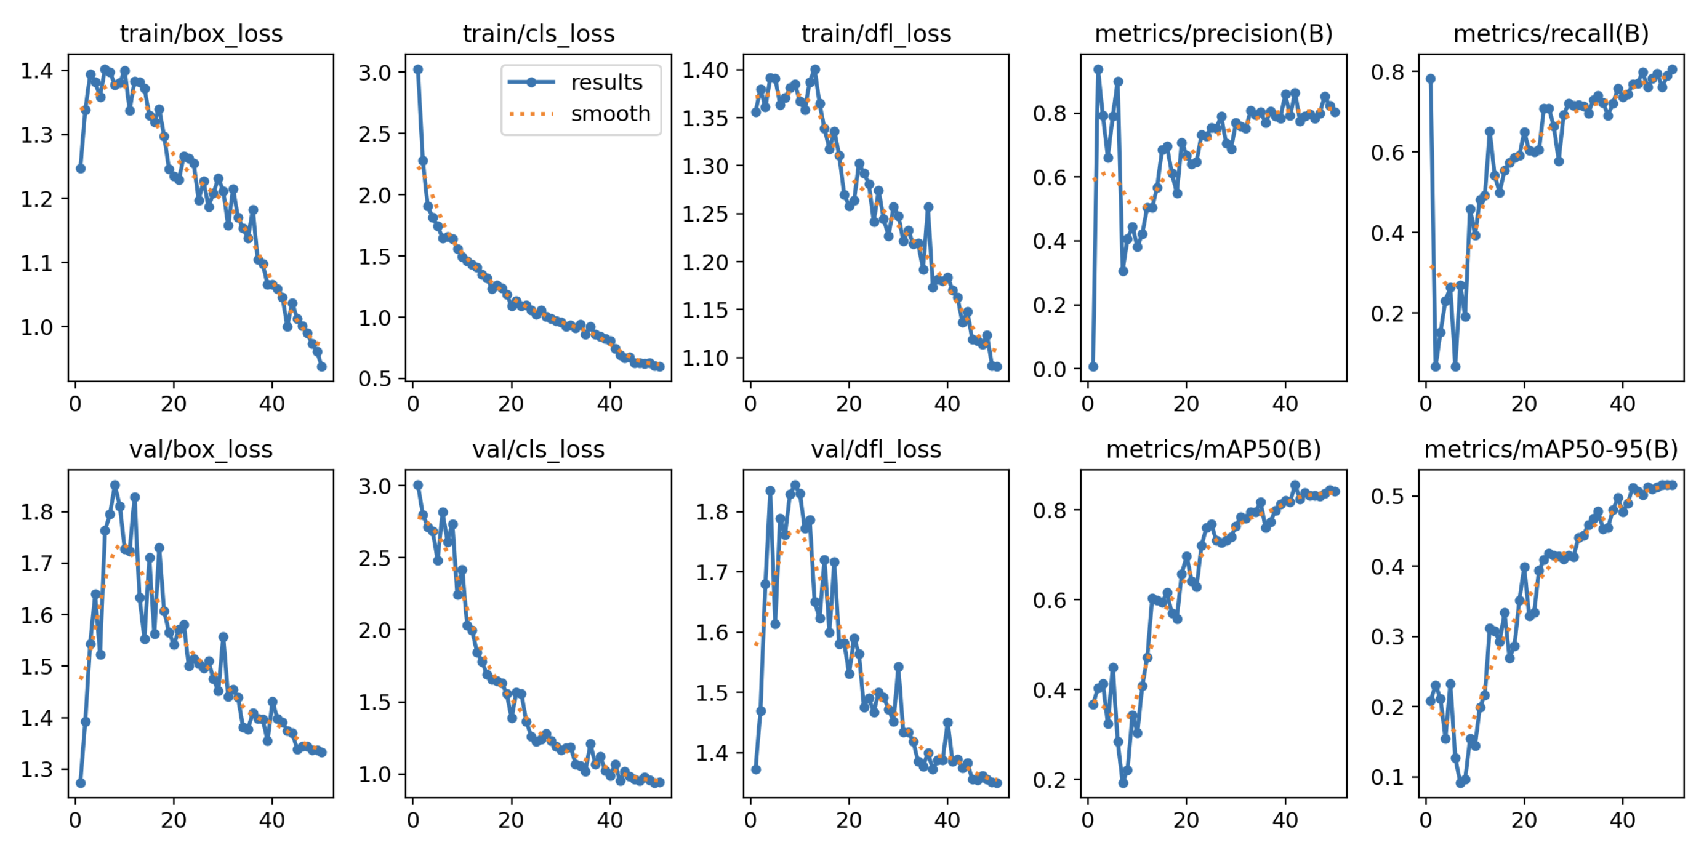
Figure A1: Object detection model training metrics

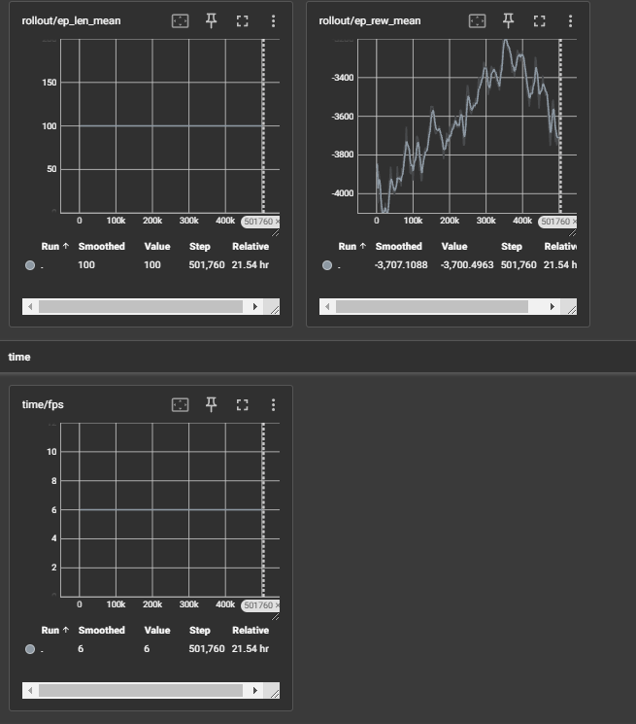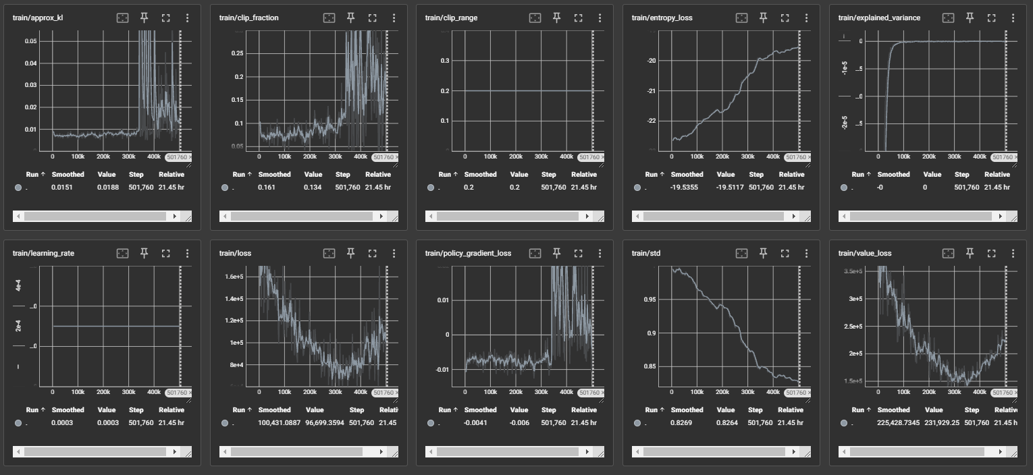
Figure A2: RL Single experiment training metrics
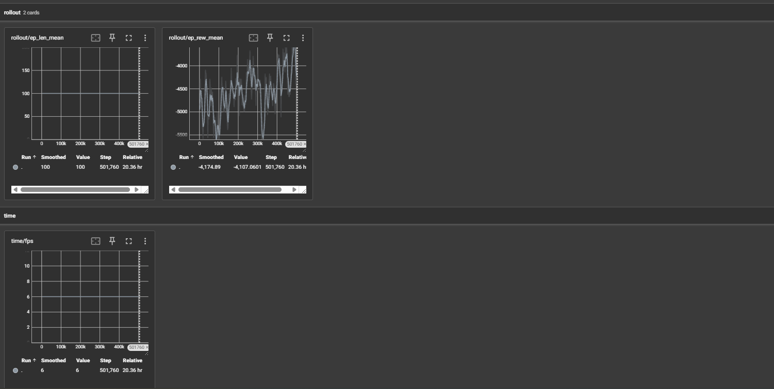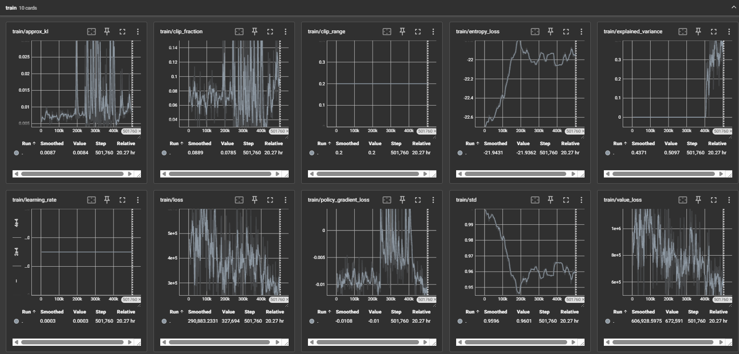
Figure A3: RL All experiments training metrics

